
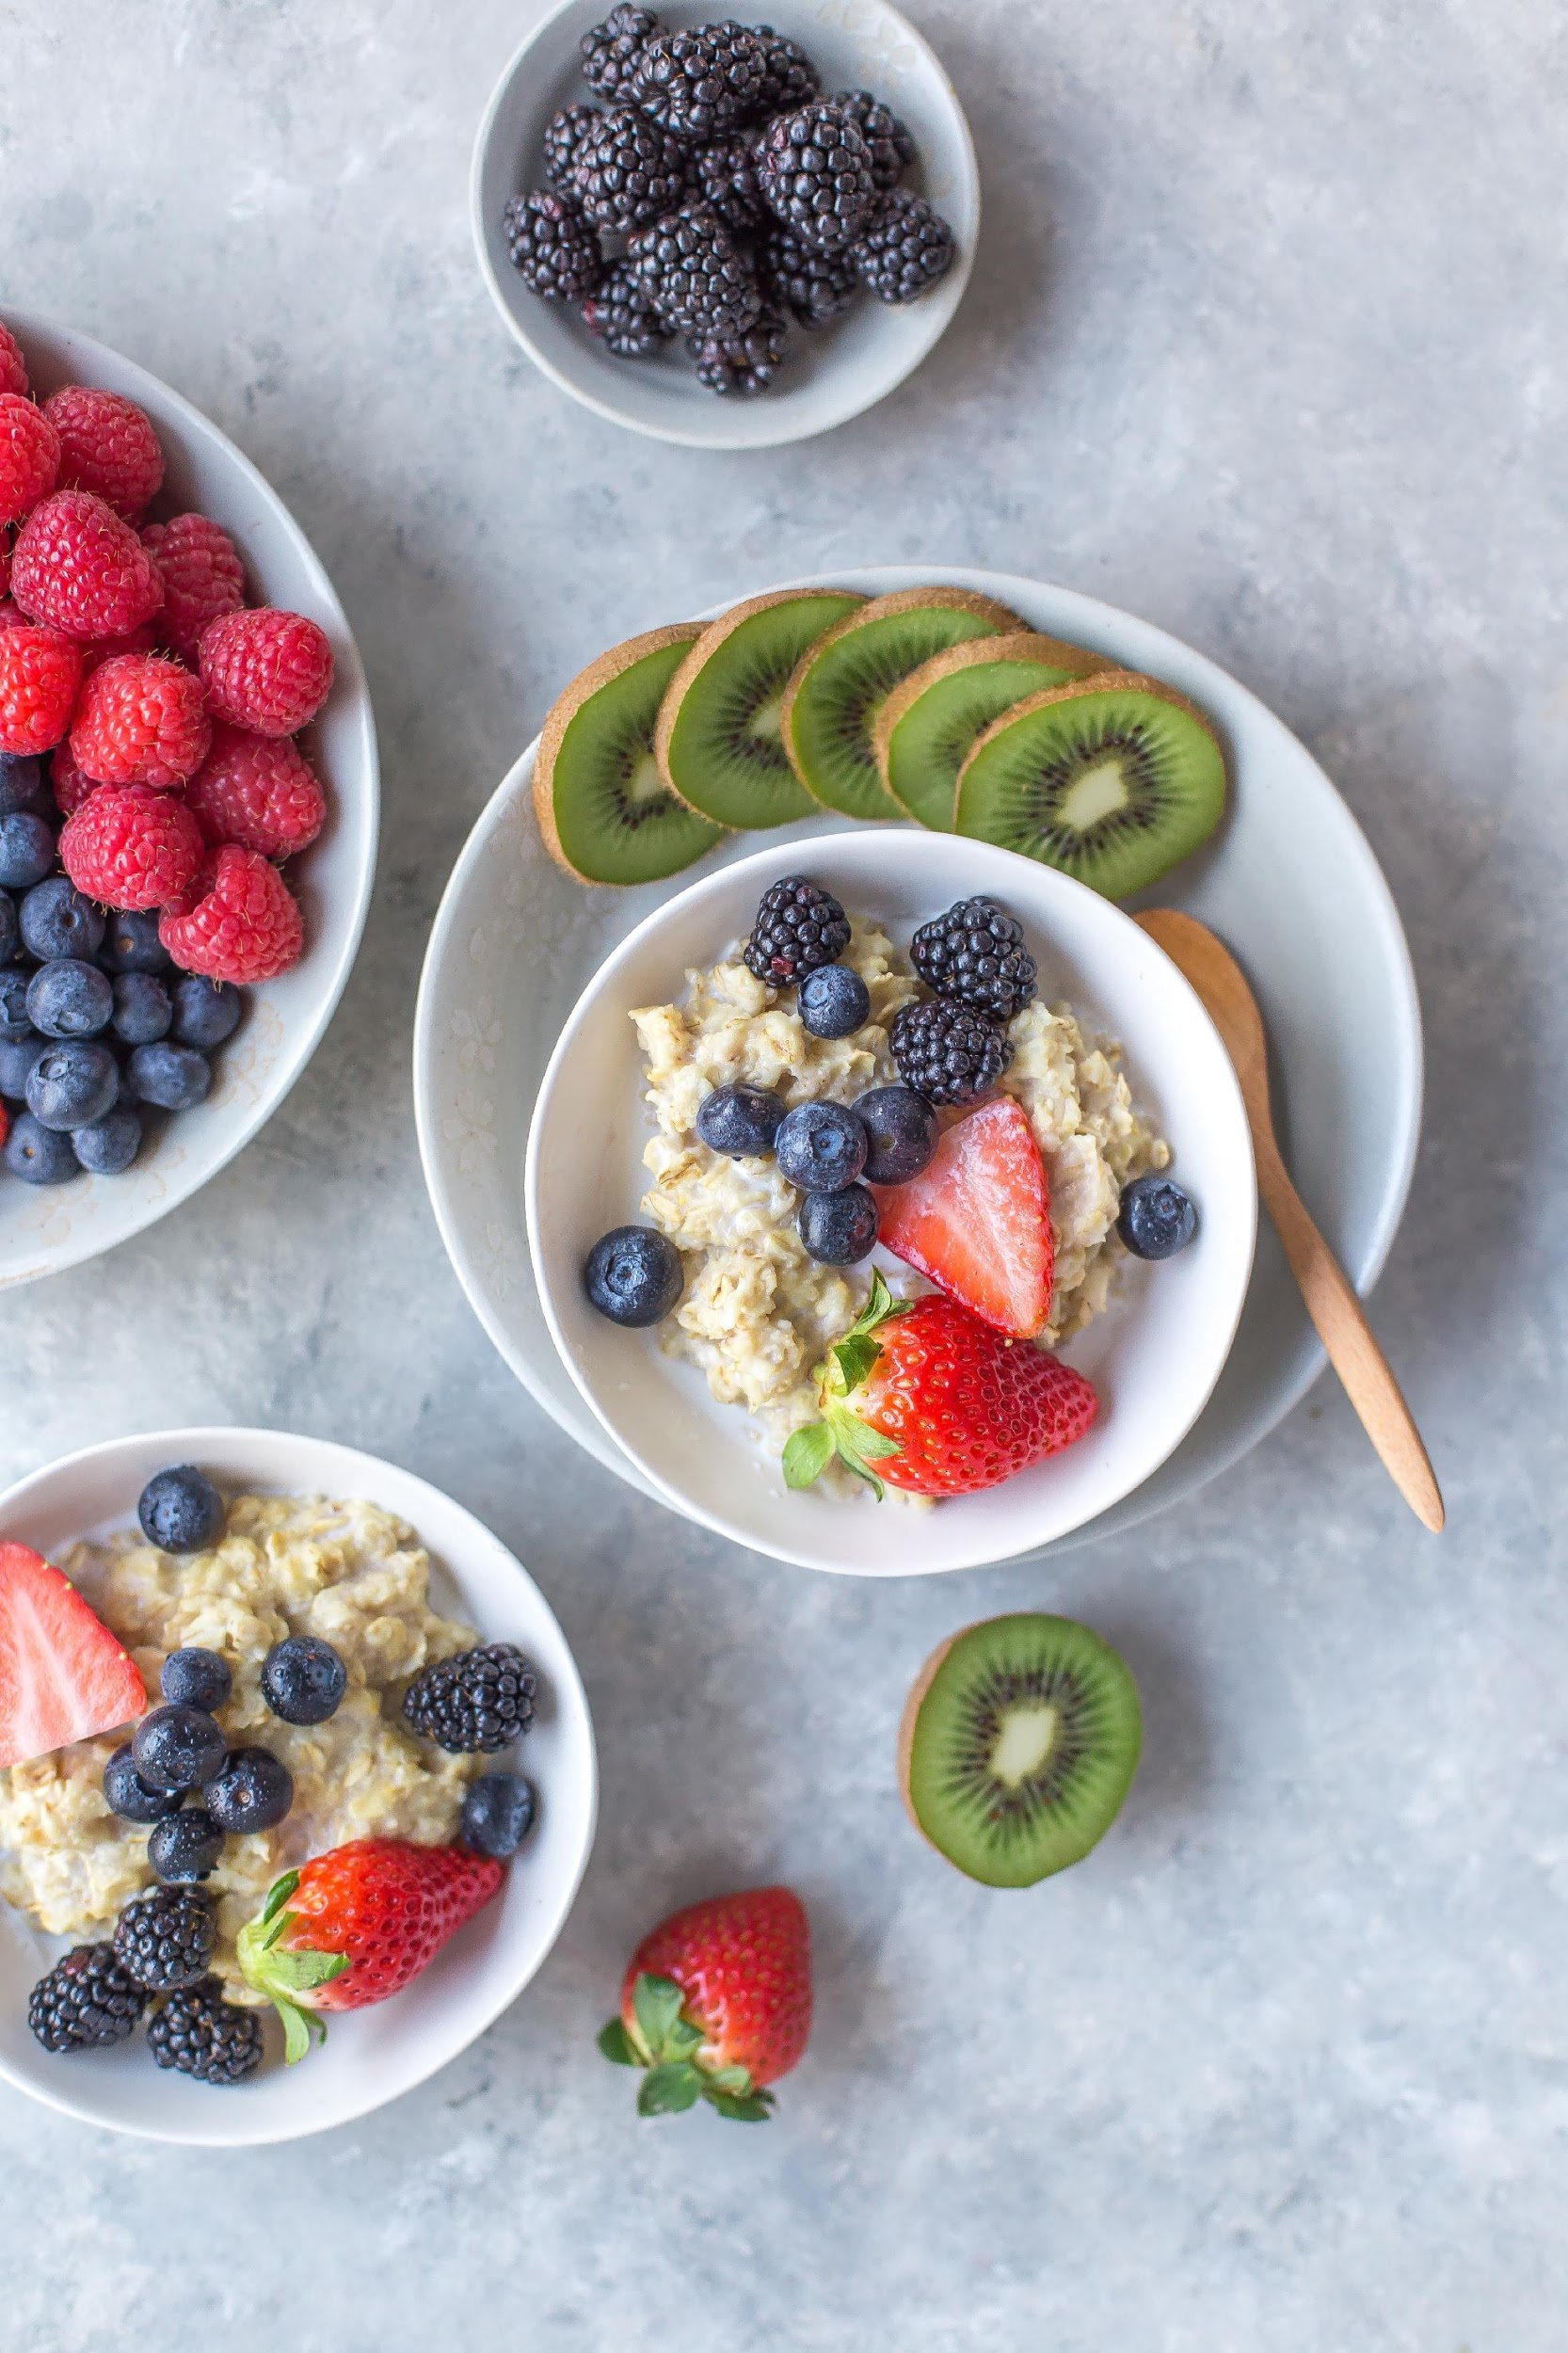

THE
CLEAN EATING
MEAL PLAN
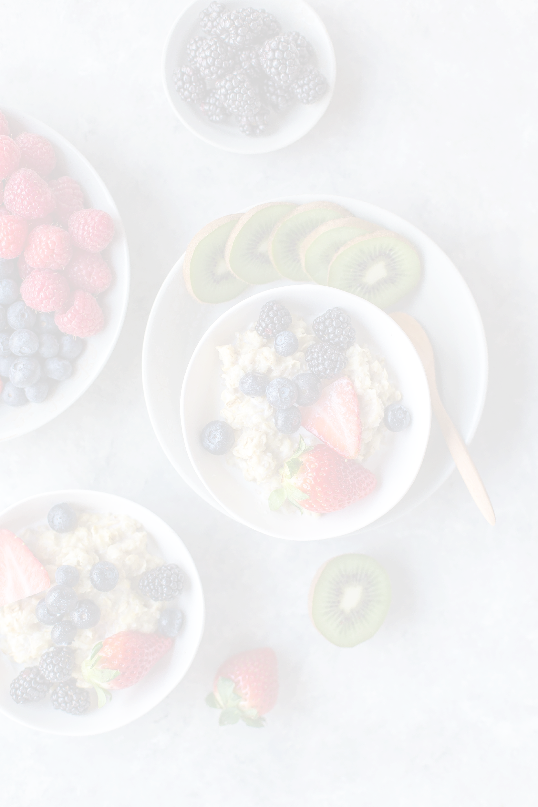

TABLE OF CONTENTS

The Clean Eating Guide
Pages 3-7

The Recipes
Pages 8-40

The Meal Plan
Pages 41-43
The Grocery Lists
Pages 44-49

THE
CLEAN EATING
GUIDE

The basic principle of clean eating is trying to eat to the best of your ability, whole, fresh, unprocessed foods. Food that occurs in nature and don’t go through extensive processing.

Preparing the food by yourself will help your chances of being successful on a clean eating plan. Going out to restaurants is not restricted but unfortunately the food served there is not as fresh and most likely processed, resulting in less nutritional value. If you are not used to cooking in the kitchen start with basics and move up from there.

A clean diet can be a little bit different for everyone but there is one thing that all clean eaters would agree on: The white stuff has to go! This includes all white sugar and white flour products. These foods provide absolutely no nutritional value. Whole foods actually fill you up and fuel you, whereas the white stuff fill a mental craving but don’t physically fill you up. These foods also make it very hard to keep your blood sugar levels stable. When your blood sugar is too high or too low it will cause cravings and may also cause symptoms like irritability and fatigue. This will make staying on a clean eating plan more difficult.

Eat enough and eat on a regular basis. Don’t let your body get to hungry or else it will be really hard to not cheat or grab a high energy convenient food. Eating on a regular basis will also help you regulate your blood sugar levels. The meal plan included in this plan contains four meals. Three main meals and one snack which should be plenty to fuel you through the day.

It’s all about balance and your plate should reflect that. Try to eat a balanced amount of proteins, fats and carbohydrates at every meal. Fill your plate up with an unlimited amount of vegetables, add in quality sources of protein, complex carbs and healthy fats.

The clean eating approach understands that not all calories are equal. When you only consume whole foods you are much more likely to not over consume and maintain a healthy weight. Eating whole foods will provide your body with the nutrients it needs to keep your body not only at a healthy weight but also overall healthy. Whole foods contain an abundance of vitamin and minerals like Vitamin A, C, D and K, B12, magnesium and calcium. Of course you could take supplements for these but the nutrients are absorbed much better when consumed through food versus pill form.
WHAT IS CLEAN EATING?
PANTRY AND FRIDGE STAPLES
VEGETABLES
Asparagus
Broccoli
Carrots
Cauliflower
Celery
Cucumber
Garlic
Green Onions
Jalapeño
Kale
Mushrooms
Mixed Spring Greens
Red Bell peppers
Red cabbage
Red Onions
Spaghetti Squash
Spinach
Sweet Potato
Tomatoes
White Onions
Zucchini
FRUIT
Apples
Avocado
Bananas
Blackberries
Blueberries
Dates
Grapefruit
Grapes
Kiwi
Lemon
Lime
Mango
Melon
Orange
Peach
Pear
Pineapple
Pomegranate
Strawberries
Raspberries
Watermelon
ANIMAL PRODUCTS
Chicken
Turkey
Eggs
Beef
Bison
Lamb
Pork
Lamb
FISH
Shrimps
Wild Caught Salmon
Tuna Steak
Canned Tuna
Canned Sardines
GRAINS
Brown Rice
Brown Rice Pasta
Brown Rice Tortilla Wrap
Gluten Free Oatmeal
BEANS & LEGUMES
Black Beans
White Beans
Chickpeas
Lentils
NUTS & SEEDS
Almonds
Walnuts
Chia Seeds
Flaxseeds
Pumpkin Seeds
OILS
Coconut Oil
Extra Virgin Olive Oil
Avocado Oil
Sesame Seed Oil
EXTRAS
Almond Milk
Canned Coconut Milk
Nut Butters
Coconut Aminos
Honey
Protein Powder
Raw Cacao Powder
Tahini
Tomato Paste
Apple Cider Vinegar
Honey Dijon Mustard

The more organic products you can include in your diet the better, but of course not everyone has the budget for it. Eat organic as much as you can but never avoid buying fruits or vegetables just because you can’t afford the organic version.

The Environmental Working Group releases a Clean 15 and Dirty Dozen list every year showing us which fruits and vegetables have the most and the least pesticides added to our food. I recommend referring to this list while grocery shopping to minimize your exposure to toxins and cut on cost.
CLEAN 15
Avocado
Sweet Corn
Pineapple
Cabbage
Frozen Sweet Peas
Onions
Asparagus
Mangos
Papayas
Kiwi
Eggplant
Honey Drew Melon
Grapefruit
Cantaloupe
Cauliflower
DIRTY DOZEN+
Strawberries
Apples
Nectarines
Peaches
Celery
Grapes
Cherries
Spinach
Tomatoes
Sweet Bell Peppers
Cherry Tomatoes
Cucumbers
Hot Peppers
Kale and Collard Greens
CLEAN 15 / DIRTY DOZEN BY EWG
Committing to a clean eating lifestyle doesn't mean you will never be able to attend social events or dine out again. When you switch to a clean eating lifestyle you have to make sure that it fits into your lifestyle. Although going out every night of the week is not recommended, going out once in a while will be healthy for you if it’s something you really enjoy.

It’s a matter of making the right choices. Look for dishes like stir-fries and salads on the menu. If you can’t find anything on the menu that is clean eating approved here are some examples of things you can order separately.

Protein
Grilled Chicken Breast
Grilled Salmon Fillet
Steak
Hamburger without the bun

Carbs
Baked Potato
Baked Sweet Potato Fries
Quinoa
Brown Rice

Fats
Avocado or Guacamole
Nuts and Seeds (Great on salads)
Olive Oil

Beverages
Water
Sparkling Water
Tea
Coffee
Most of the restaurants will have all of these foods in the kitchen even if it’s not written exactly like that on the menu. Don’t be shy to ask for something a little different. When it comes to your health it’s always worth it. The last tip for eating out on a clean eating diet is to ALWAYS ask for the dressing on the side. Most restaurants add way more than needed. Even if it’s a healthy dressing I recommend doing this.
EATING OUT WHILE ON A CLEAN EATING DIET

THE
CLEAN EATING
RECIPES
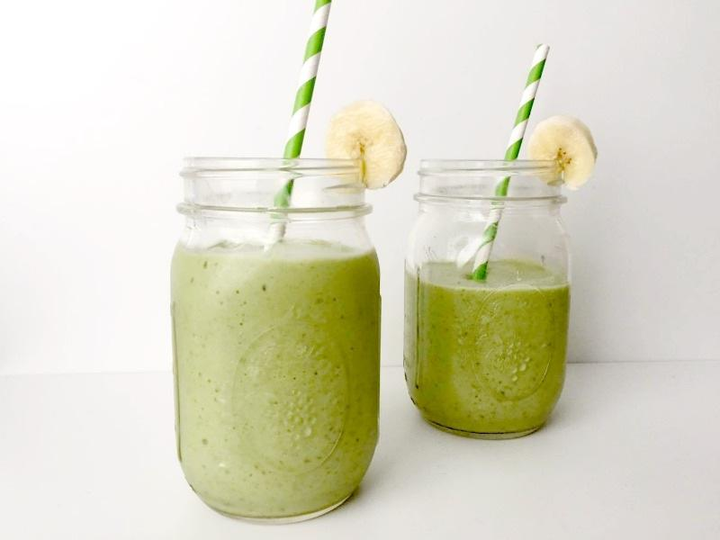
DIRECTIONS
Start by pouring the almond milk into the blender to avoid the ingredients sticking at the bottom of the blender.
Next add in the banana, avocado, spinach, chia seeds and the protein powder.
Turn the blender on, starting at a low speed and increase as needed.
Once the liquid looks even, pour into a cup and enjoy immediately to conserve as many nutrients as possible.
INGREDIENTS
1/2 Frozen Banana
1 Cup of Spinach
1/2 Avocado
1 Serving of Vanilla Protein Powder
1 Cup of Almond Milk
1 Tbsp of Chia Seeds
NUTRITIONAL VALUE
Fat: 20 g
Carbs: 28 g
Protein: 42 g
Total Calories: 430 Calories
GREEN PROTEIN SMOOTHIE
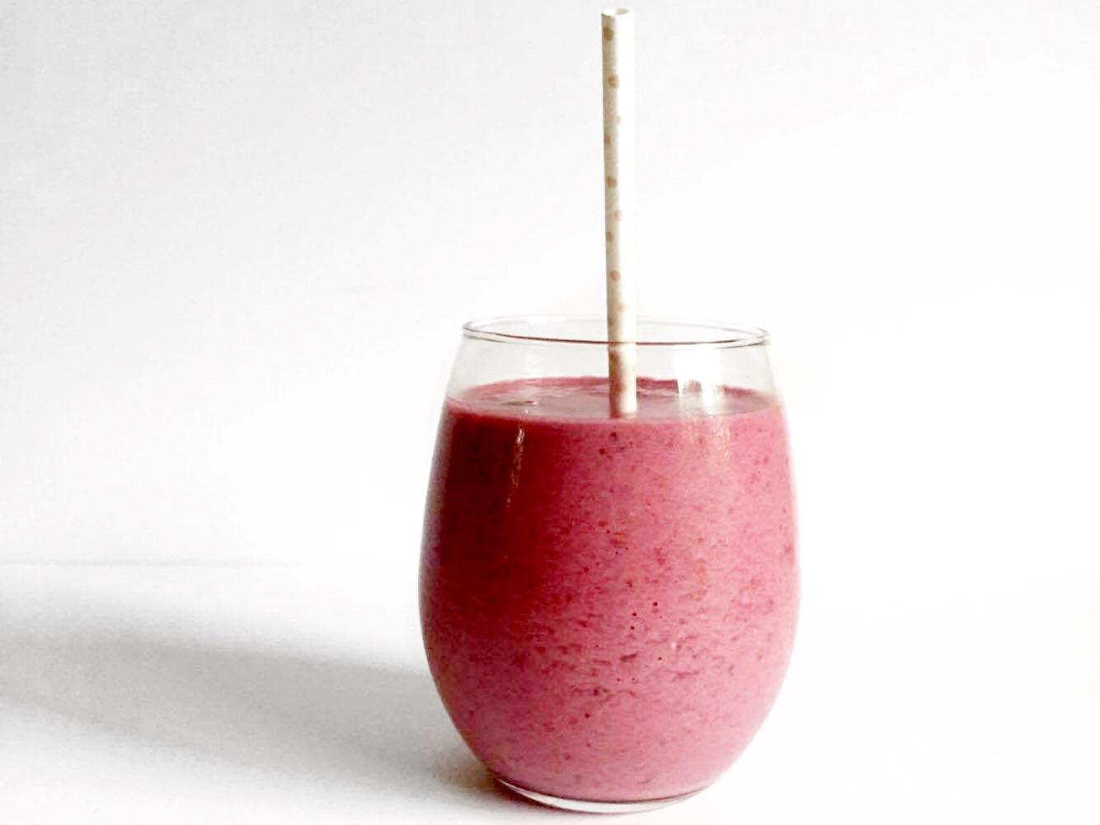
RASPBERRY COCONUT SMOOTHIE
INGREDIENTS
1 Cup of Raspberries
1/2 Frozen Banana
1 Tbsp of Chia Seeds
1 Cup Coconut Milk
1 Serving of Vanilla Protein Powder
NUTRITIONAL VALUE
Fat: 10 g
Carbs: 54 g
Protein: 41 g
Total Calories: 448 Calories
DIRECTIONS
Start by pouring the coconut milk into the blender to avoid the ingredients sticking at the bottom of the blender.
Next add in the banana, raspberries, chia seeds and the protein powder.
Turn the blender on, starting at a low speed and increase as needed.
Once the liquid looks even, pour into a cup and enjoy immediately to conserve as many nutrients as possible.
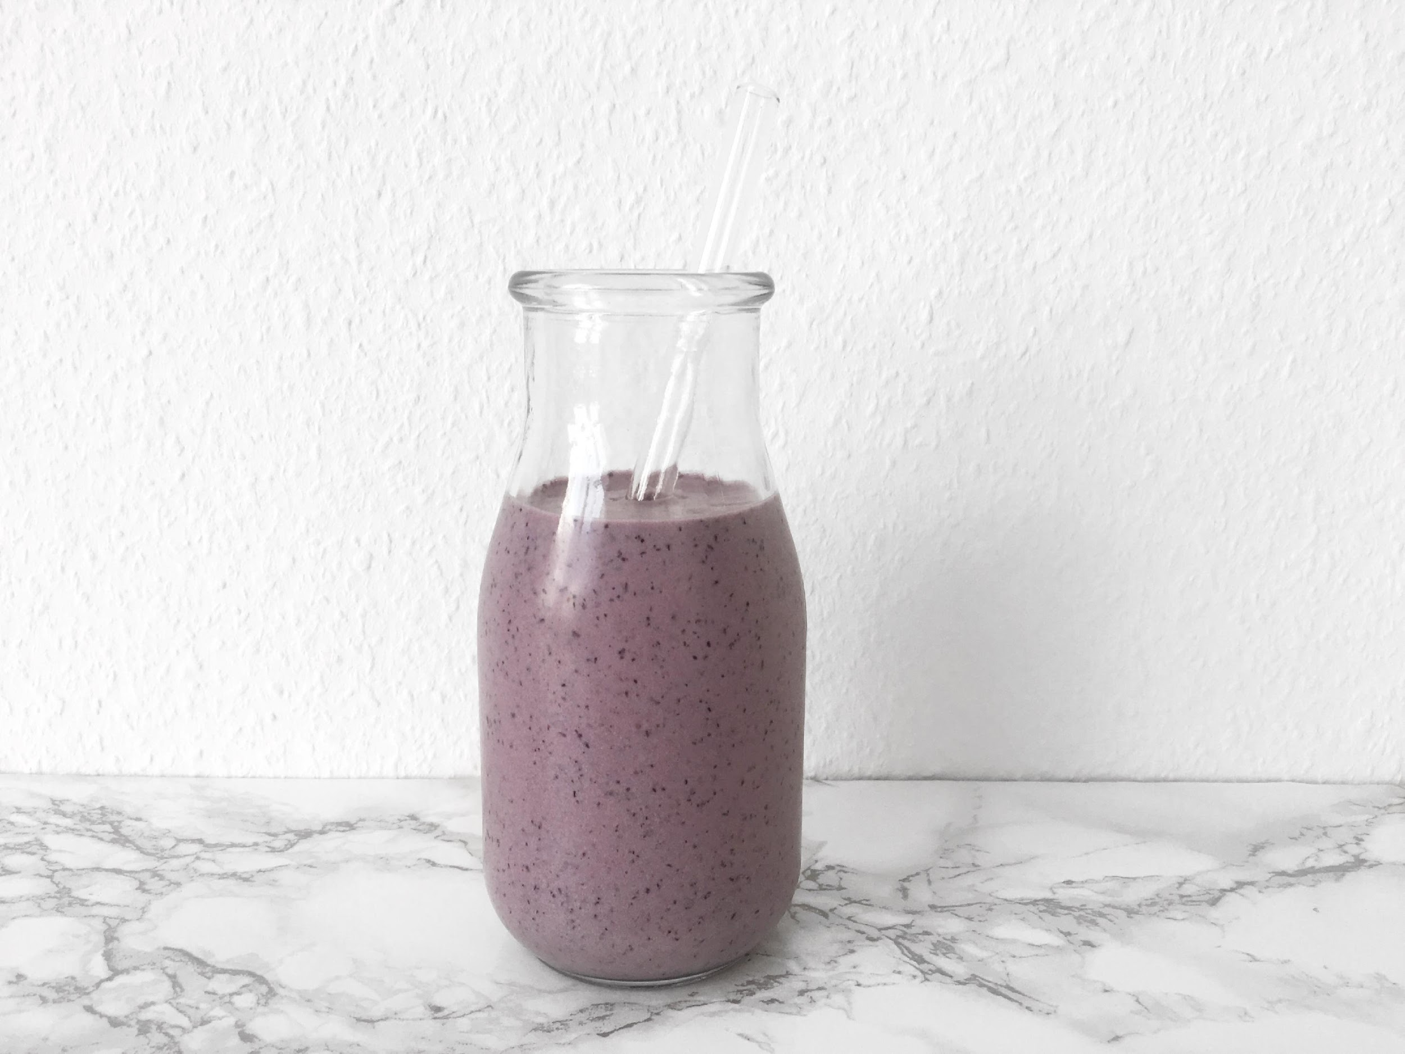
INGREDIENTS
1 Cup of Blueberries
1 Banana
1 Cup of Coconut Milk
1 Serving of Vanilla Protein Powder
Handful of Ice
BLUEBERRY SMOOTHIE
NUTRITIONAL VALUE
Fat: 18 g
Carbs: 53 g
Protein: 20 g
Total Calories: 436 Calories
DIRECTIONS
Start by pouring the coconut milk into the blender to avoid the ingredients sticking at the bottom of the blender.
Next, throw in the blueberries, banana, collagen powder and the ice. Turn the blender on, starting at a low speed and increase as needed.
Once the liquid looks even, pour into a cup and enjoy immediately to conserve as many nutrients as possible.
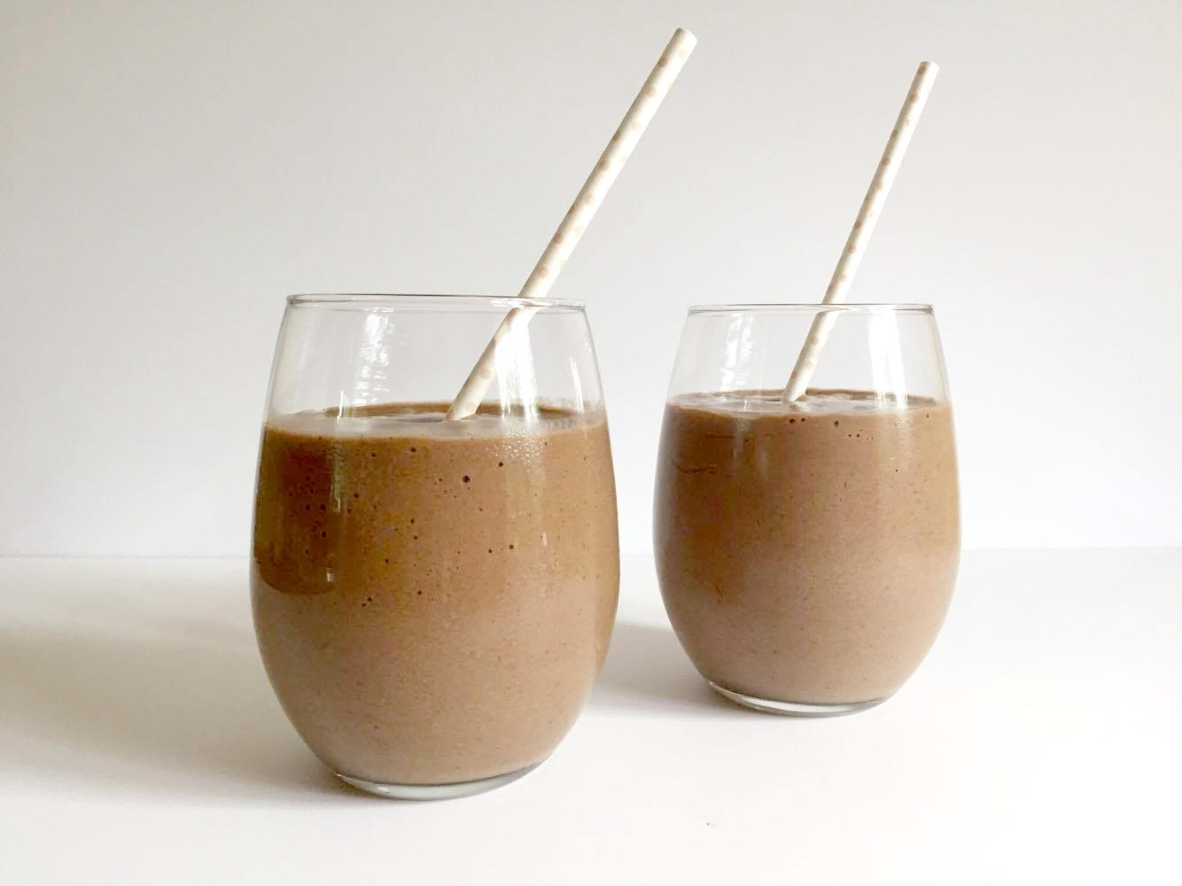
CHOCOLATE BANANA SMOOTHIE
INGREDIENTS
1 Frozen Banana
1/2 Avocado
1 Cup of Almond Milk
2 Tbsp of Raw Cacao Powder
1 Serving Chocolate Protein Powder
NUTRITIONAL VALUE
Fat: 10 g
Carbs: 54 g
Protein: 41 g
Total Calories: 448 Calories
DIRECTIONS
Start by pouring the almond milk into the blender to avoid the ingredients sticking at the bottom of the blender.
Next, throw in the banana, avocado, cacao powder and the protein powder. Turn the blender on, starting at a low speed and increase as needed.
Once the liquid is even pour into a cup and enjoy immediately to conserve as many nutrients as possible.
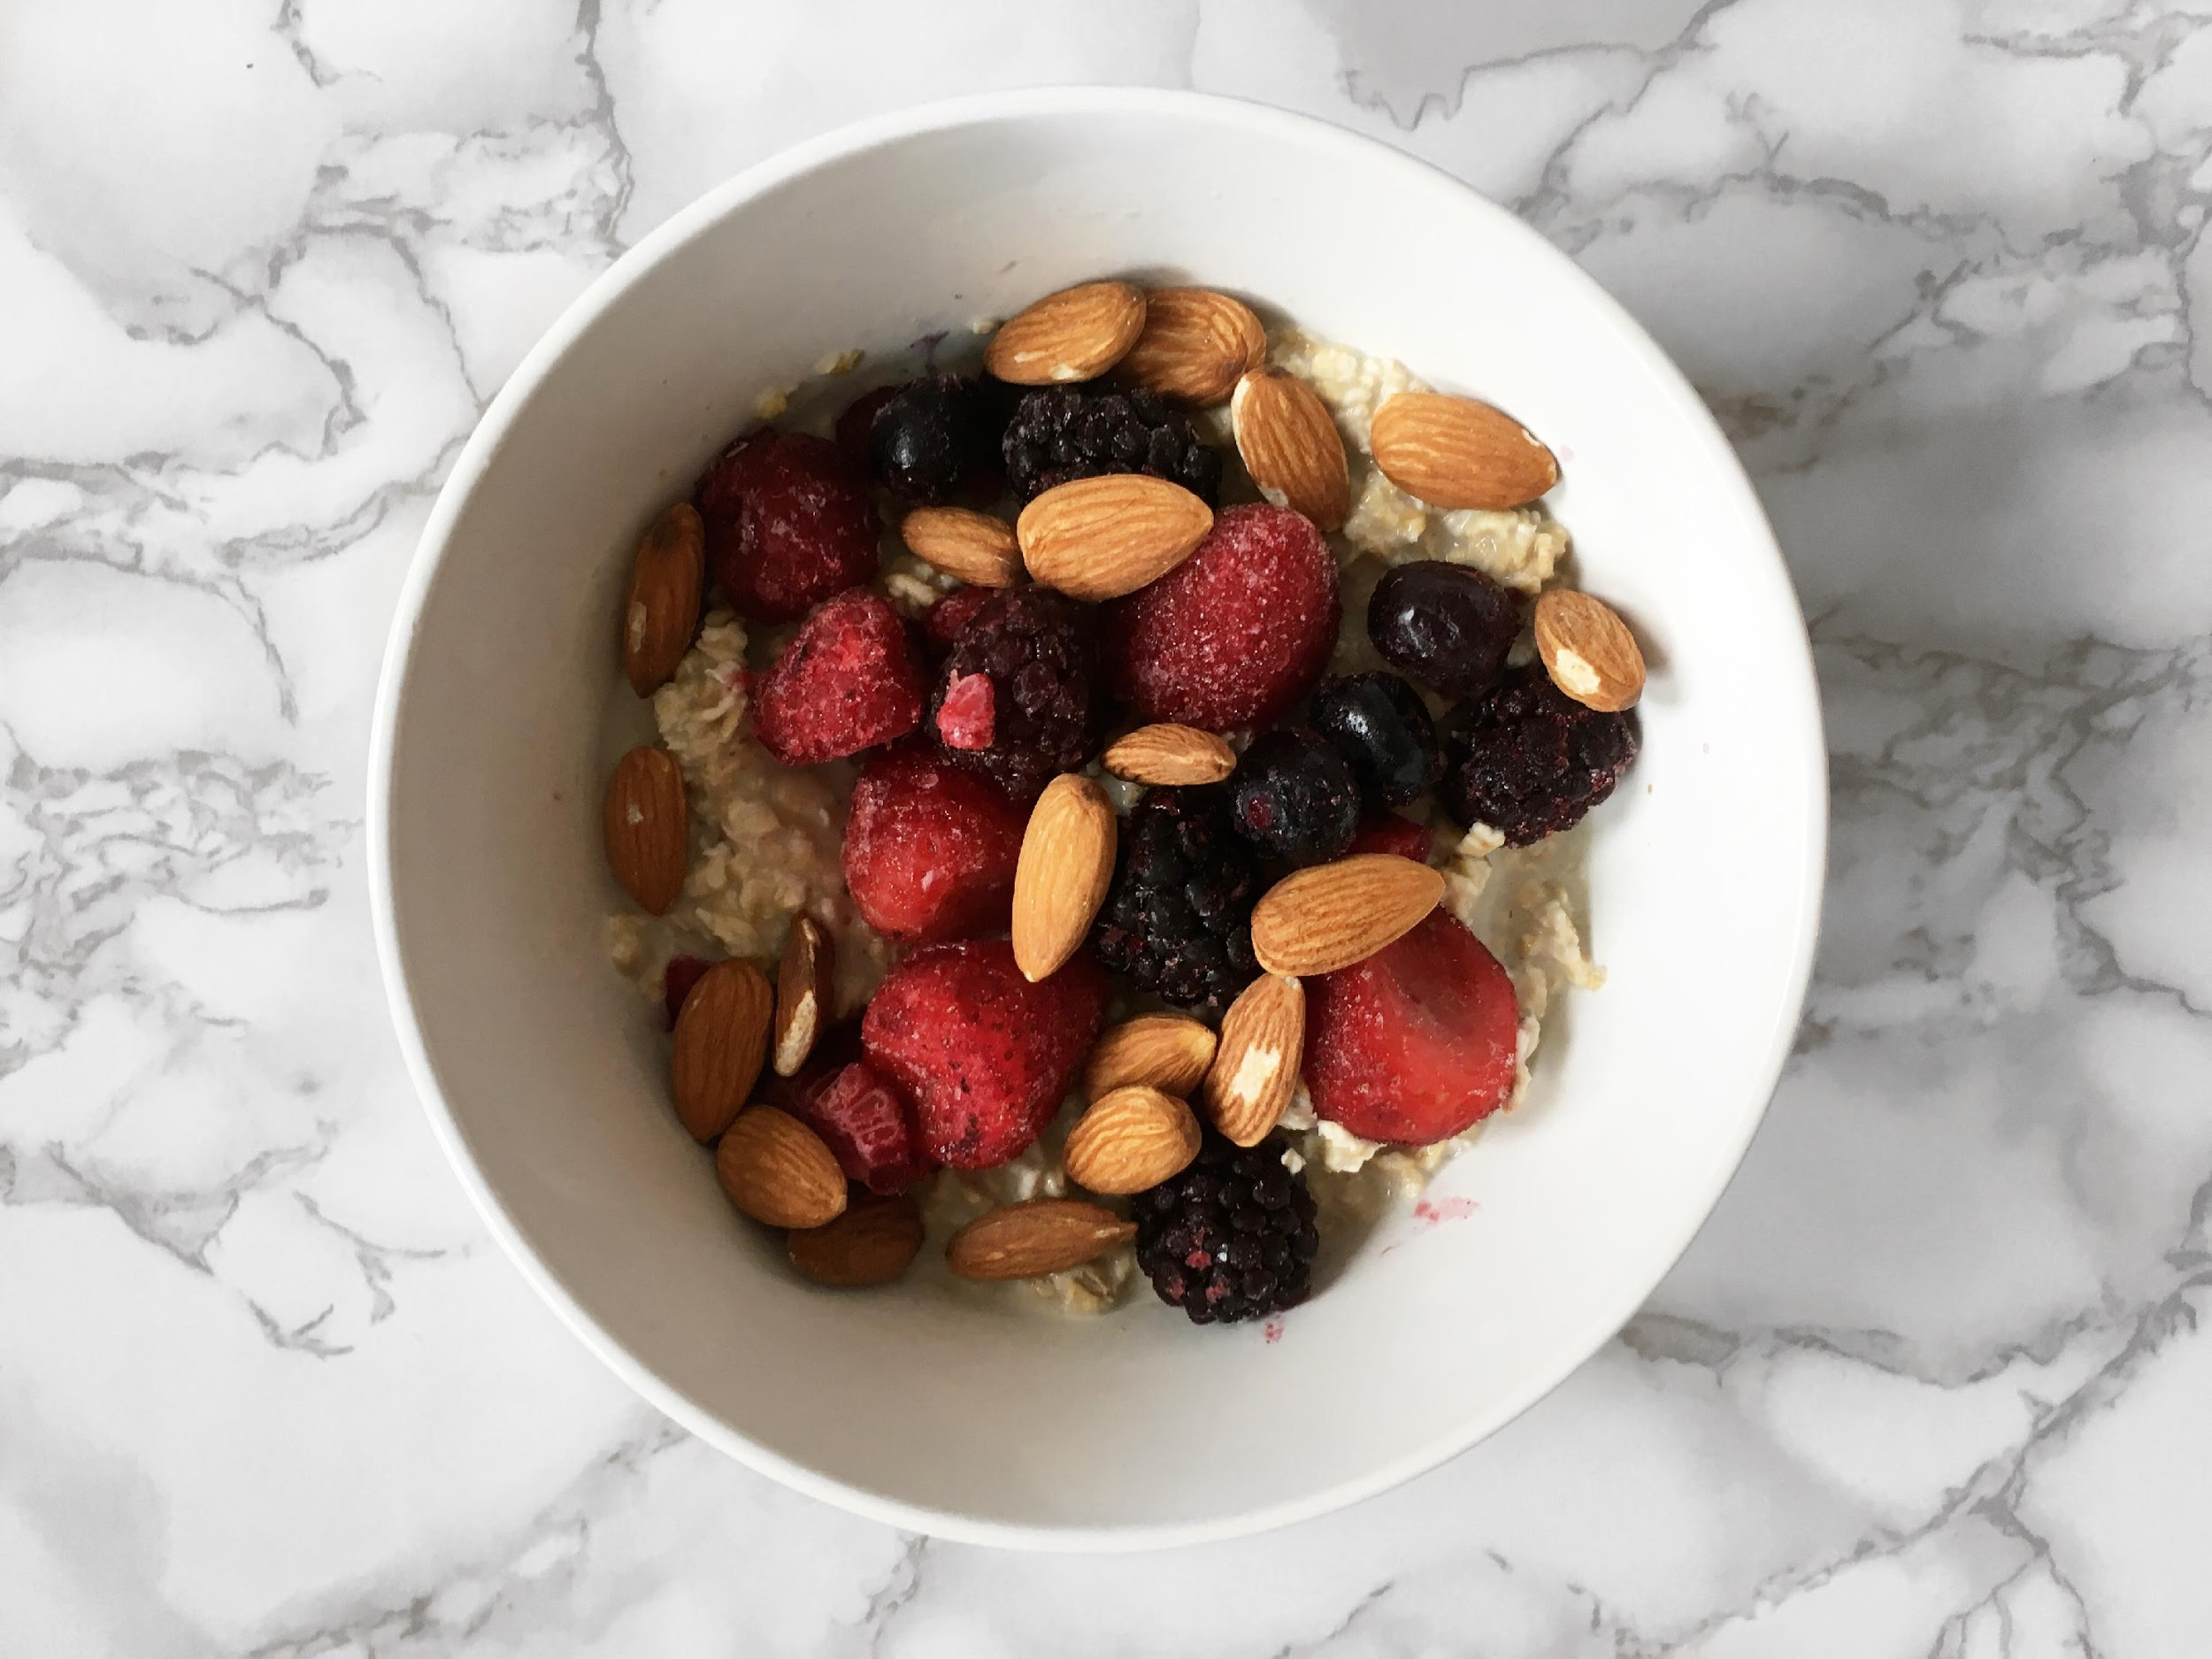
SUPERFOOD OATMEAL
INGREDIENTS
1/2 Cup of Gluten Free Oatmeal
1 Cup of Almond Milk
1/4 Cup of Almonds
1/2 Cup of Berries
1 tsp of Ground Cinnamon
NUTRITIONAL VALUE
Fat: 21 g
Carbs: 40 g
Protein: 12 g
Total Calories: 401 Calories
DIRECTIONS
In a pot place the oats, cinnamon and the almond milk and turn the heat on high until it starts boiling.
Once it is boiling turn the heat down to low and stir until all of the almond milk is absorbed.
Once the oatmeal is ready transfer it into a bowl and add the nuts and fresh berries.
Optional: Add honey or extra toppings.
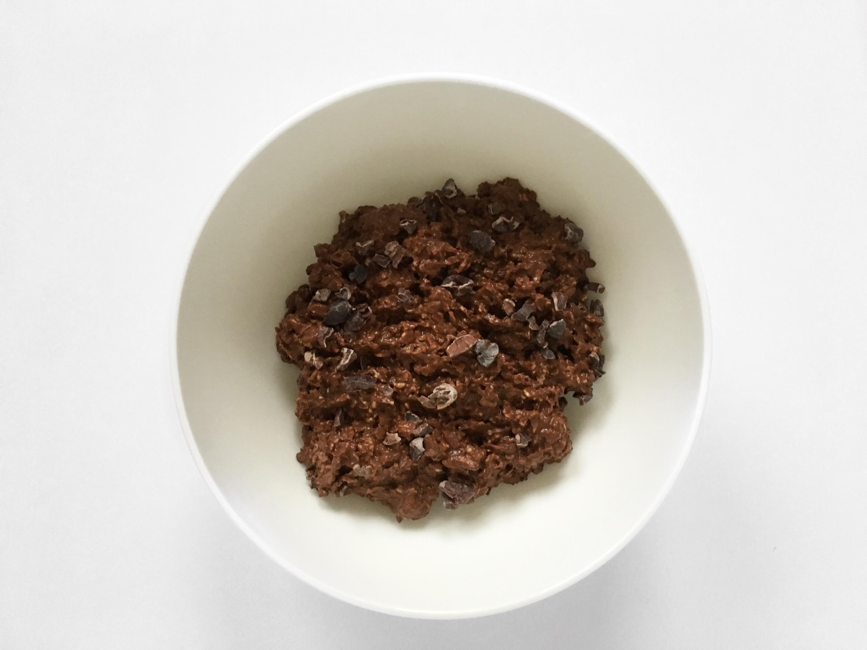
CHOCOLATE OVERNIGHT OATS
INGREDIENTS
1/2 Cup of Gluten Free Oatmeal
1 Cup of Almond Milk
1 Serving of Chocolate Protein Powder
1 Tbsp of Chia Seeds
1 Tbsp of Raw Cacao Powder
1 Tbsp of Maple Syrup
Optional: Raw Cacao Nibs
NUTRITIONAL VALUE
Fat: 18 g
Carbs: 60 g
Protein: 46 g
Total Calories: 550 Calories
DIRECTIONS
Combine all the ingredients into a mason jar or a sealed container, give it a good stir and place in the fridge overnight.
In the morning, add raw cacao nibs on top for an extra crunch if desired.
Enjoy cold or heated up.
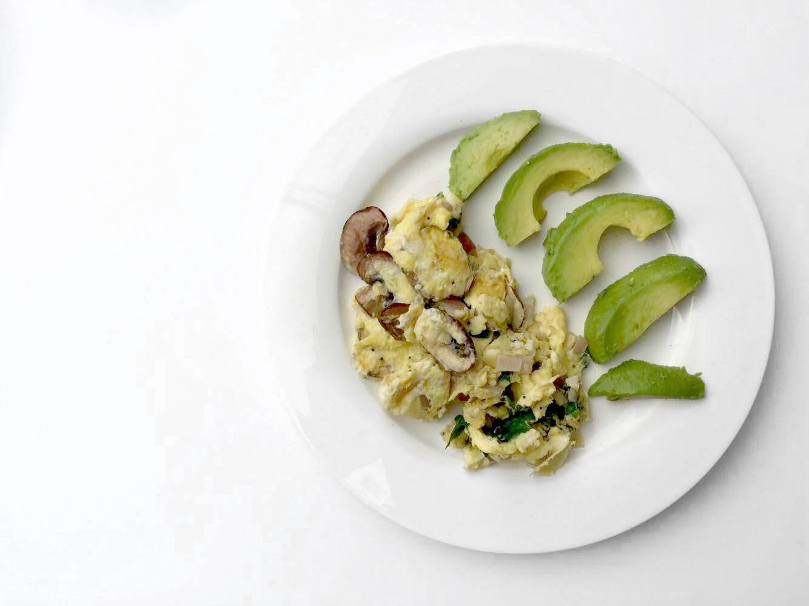
VEGGIE SCRAMBLE & AVOCADO
INGREDIENTS
2 Eggs
1 Cup of Spinach
2 Mushrooms
1/4 Red Bell Pepper
1/4 Cup of Red Onions
1/2 Avocado
1 tsp of Coconut Oil
NUTRITIONAL VALUE
Fat: 39 g
Carbs: 16 g
Protein: 16 g
Total Calories: 460 Calories
DIRECTIONS
Heat a pan on medium heat and add the coconut oil. Once the coconut oil is melted add all of the vegetables except for the spinach and cook for 3 minutes.
Next add the eggs and spinach.
Once the omelette is complete add the sliced avocado on top.
Season with salt and pepper to your desire.
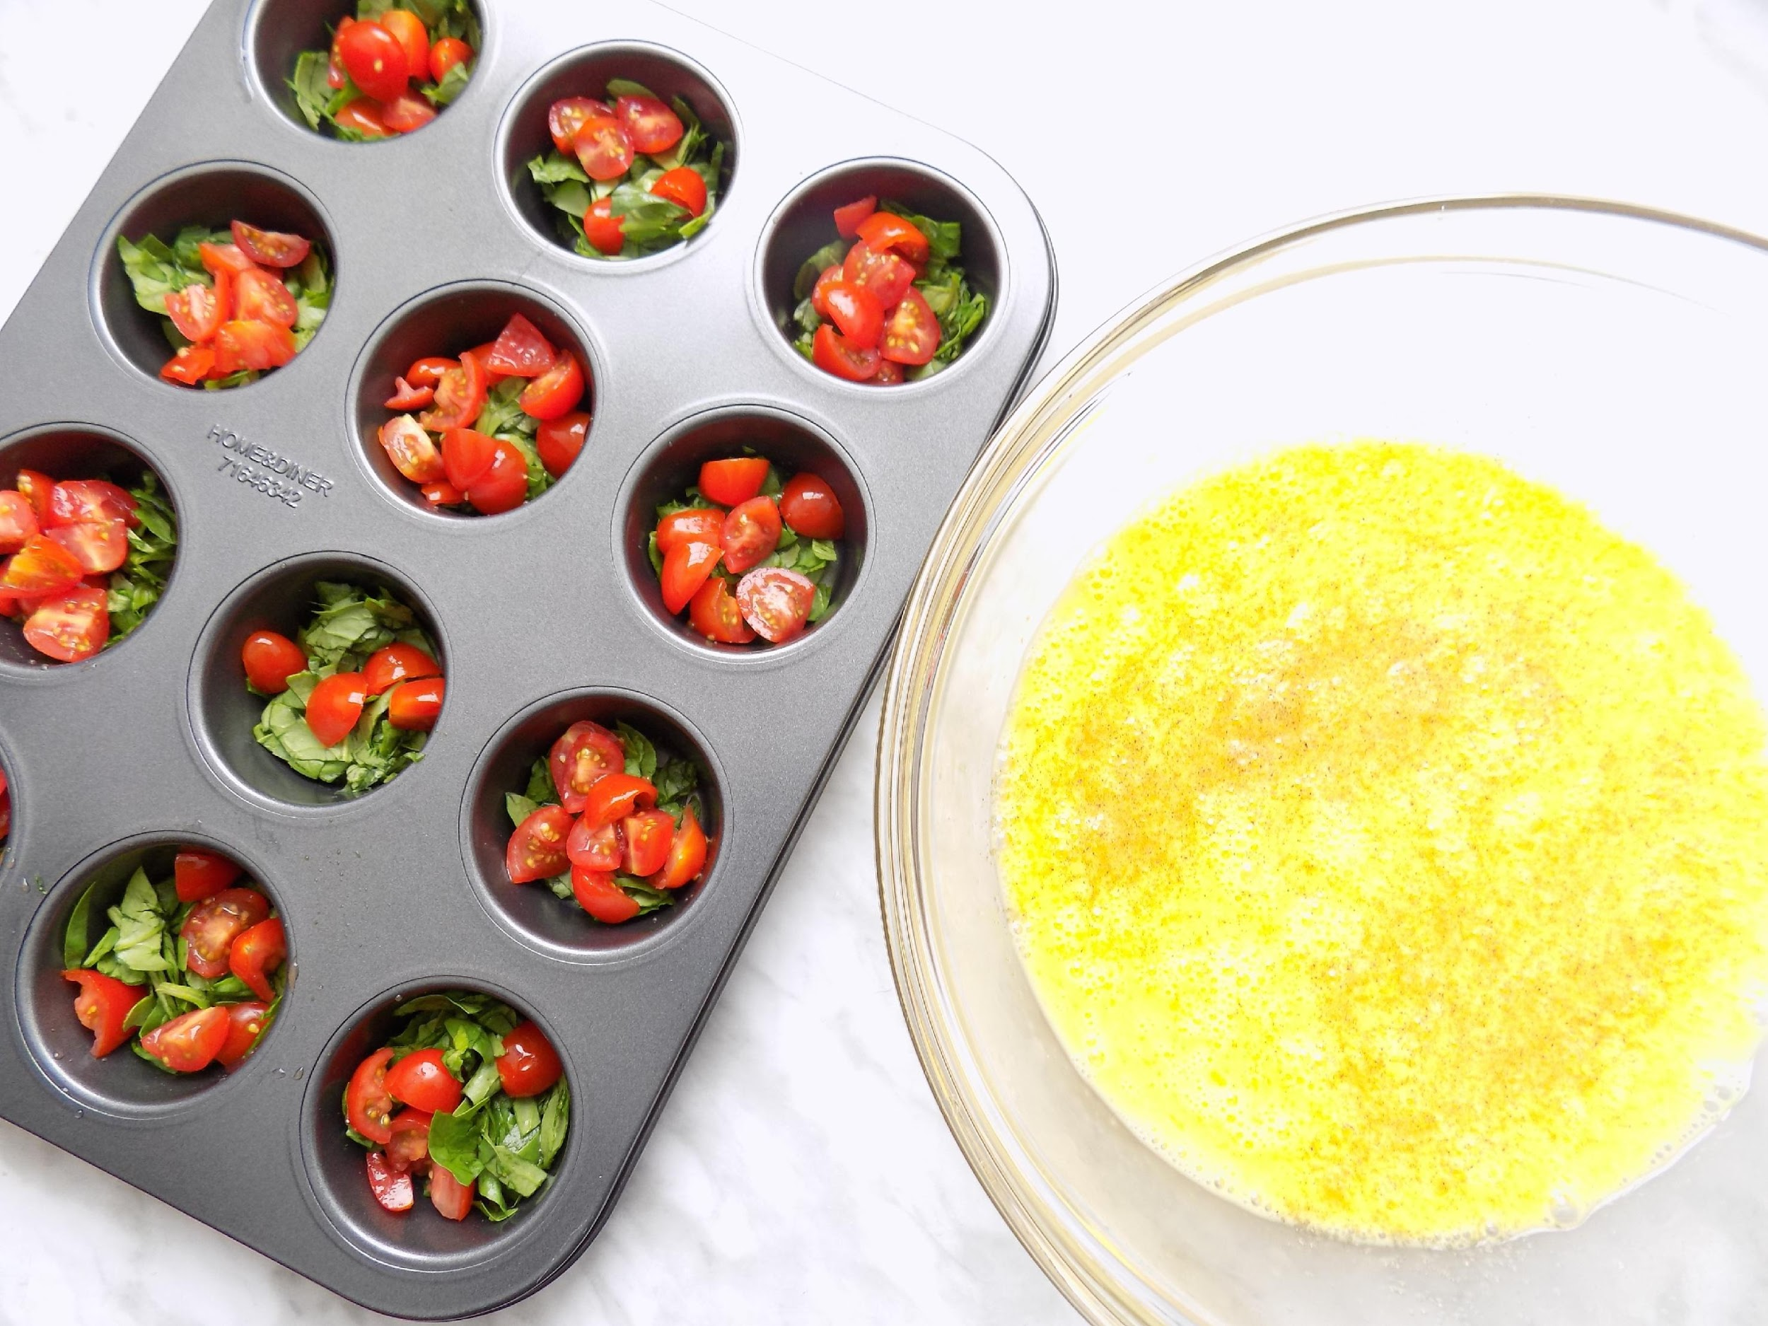
MINI OMELETTES
INGREDIENTS
3 Eggs
1/2 Cup of Spinach
1 Small Tomato
1 Tbsp of Fresh Basil
1 Tbsp of Coconut Oil
NUTRITIONAL VALUE
Fat: 29 g
Carbs: 5 g
Protein: 20 g
Total Calories: 360 Calories
DIRECTIONS
Preheat the oven at 350F/175C.
Coat a muffin tray with coconut oil to avoid sticking.
Whisk together the 3 eggs.
Chop the spinach, basil and tomatoes.
Pour the egg mixture into 3 different muffin cups. Then add a little bit of the vegetable mixture in each cup leaving about 1 cm empty at the top.
Bake in the oven for 18 minutes.

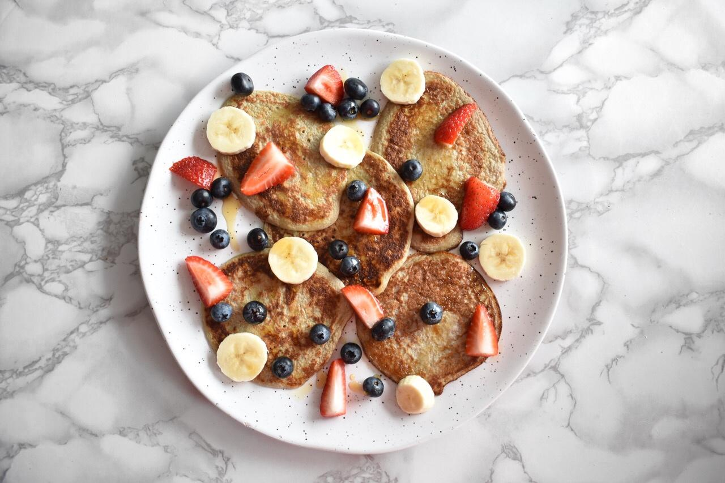
BANANA PANCAKES
INGREDIENTS
1 Banana
2 Eggs
1 Cup of Mixed Berries
1 Tbsp of Maple Syrup
1 tsp of Ground Cinnamon
1 tsp of Coconut Oil
NUTRITIONAL VALUE
Fat: 25 g
Carbs: 58 g
Protein: 15 g
Total Calories: 492 Calories
DIRECTIONS
In a bowl combine the banana, two eggs and the cinnamon. Use a hand blender or a fork to combine everything. Aim for a consistency similar to pancake batter.
Place a frying pan on medium heat and melt the coconut oil. Slowly add the batter in the pan forming 5 inch diameter pancakes. Place the cover on and cook for a couple minutes on each side.
Repeat until you have cooked the whole batch.
Top with berries and maple syrup.
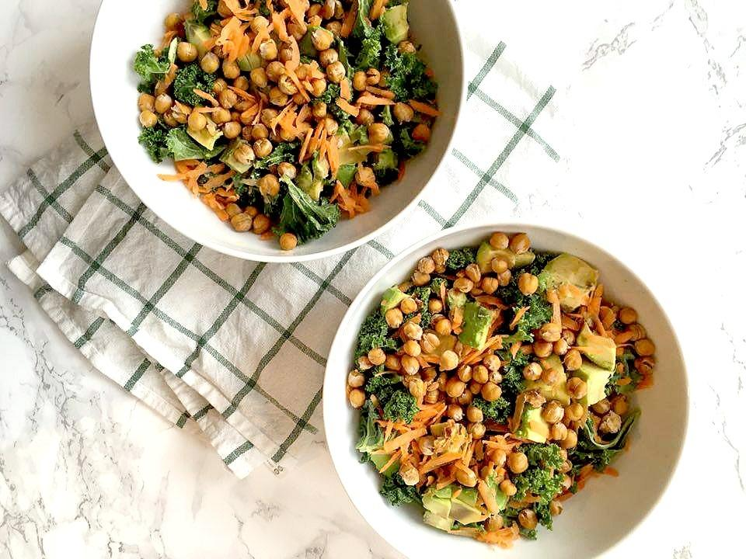
CRUNCHY KALE SALAD
INGREDIENTS
2 Cups of Kale
1 Carrot
1/2 Avocado
1/2 Cup of Chickpeas
Dressing:
1 Tbsp of Tahini
1 Tbsp of Lemon Juice
NUTRITIONAL VALUE
Fat: 22 g
Carbs: 40 g
Protein: 16 g
Total Calories: 431 Calories

DIRECTIONS
Preheat the oven to 350F/175C.
Drain and rinse the chickpeas. Dry them with a paper towel and spread them evenly on a baking tray. Bake for 45 minutes.
Meanwhile prepare the vegetables by rinsing and chopping up the kale, peeling and shredding the carrots and cutting the avocado into small cubes. Set the vegetables aside.
Combine all the dressing ingredients into a bowl and whisk together until it forms a smooth consistency.
Place all of the vegetables to a bowl with the baked chickpeas and then drizzle the dressing on top.
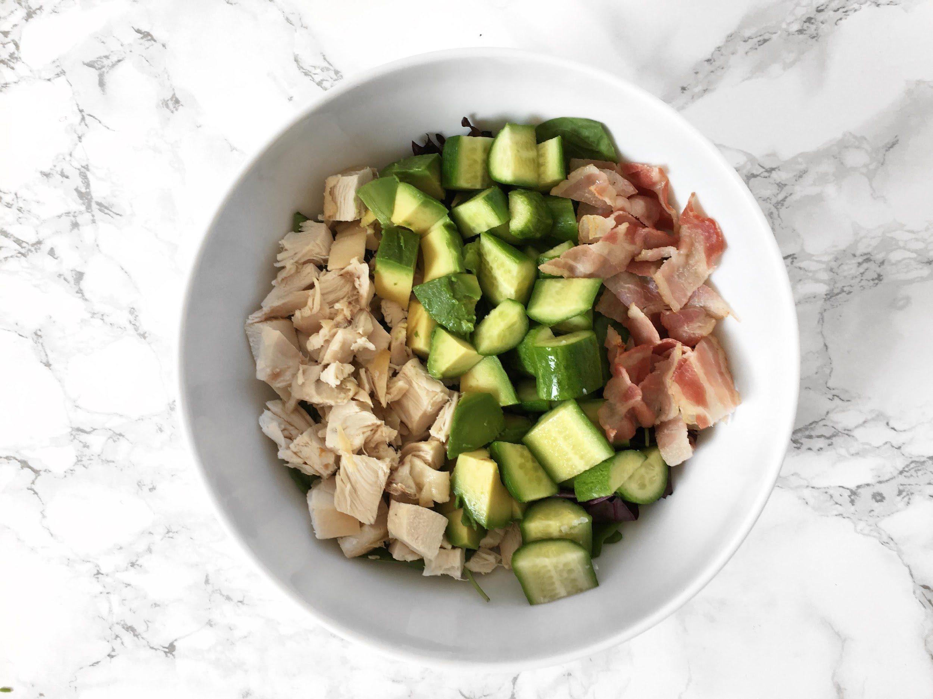
DIRECTIONS
Wash the spinach and place it at the base of a salad bowl.
Next, add all of the remaining ingredients one by one in a straight line. Lastly drizzle the olive oil on top and add the sea salt and pepper if desired.
INGREDIENTS
(2 Servings)
4 Cups of Spinach
8 oz of Chicken
2 Hard Boiled Egg
4 Slices of Bacon
1 Cup of Chopped Cucumber
1 Avocado
2 Tbsp of Extra Virgin Olive Oil
Pinch of Sea Salt and Pepper
CHICKEN COBB SALAD
NUTRITIONAL VALUE
(per serving)
Fat: 39 g
Carbs: 10 g
Protein: 39 g
Total Calories: 524 Calories
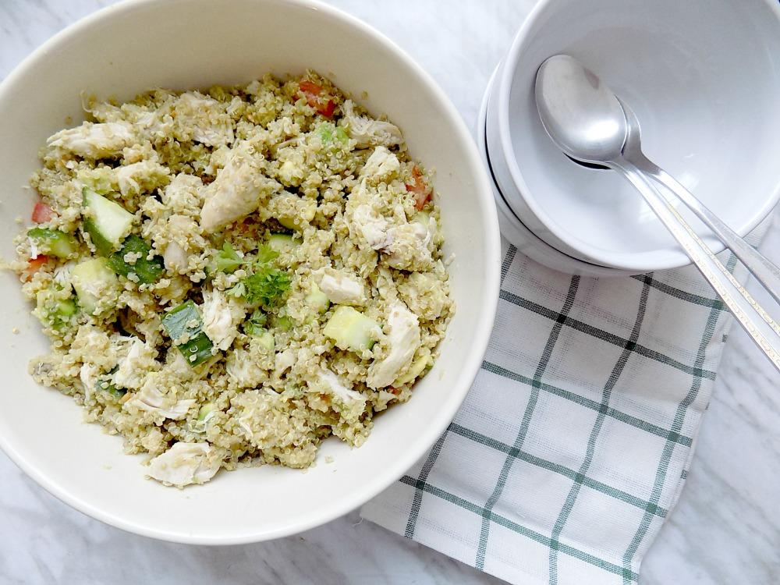
DIRECTIONS
Preheat the oven to 350F/175C.
In the oven place the chicken breast in a dish with olive oil and cover for about 30 minutes.
Measure out 1/4 cup of quinoa and add to a pot with 1/2 cup of water. Turn the heat on to high until it’s boiling then lower until all of the water has been absorbed and the quinoa is fluffy.
While the chicken and quinoa are cooking chop up the cucumber, tomatoes and avocado into small cubes. Combine all of the vegetables in a large bowl.
Once the chicken is cooked, let it cool and then chop into small pieces. Add the chicken and quinoa to the vegetables.
Mix together and add olive oil, salt and pepper to finish.
INGREDIENTS
(2 Servings)
8 oz of Chicken Breast
1/2 Cup of Quinoa
1 Tomato
1 Cup of Diced Cucumber
1 Avocado
1 Tbsp of Extra Virgin Olive Oil
CHICKEN QUINOA AVOCADO SALAD
NUTRITIONAL VALUE
(per serving)
Fat: 30 g
Carbs: 40 g
Protein: 30 g
Total Calories: 553 Calories

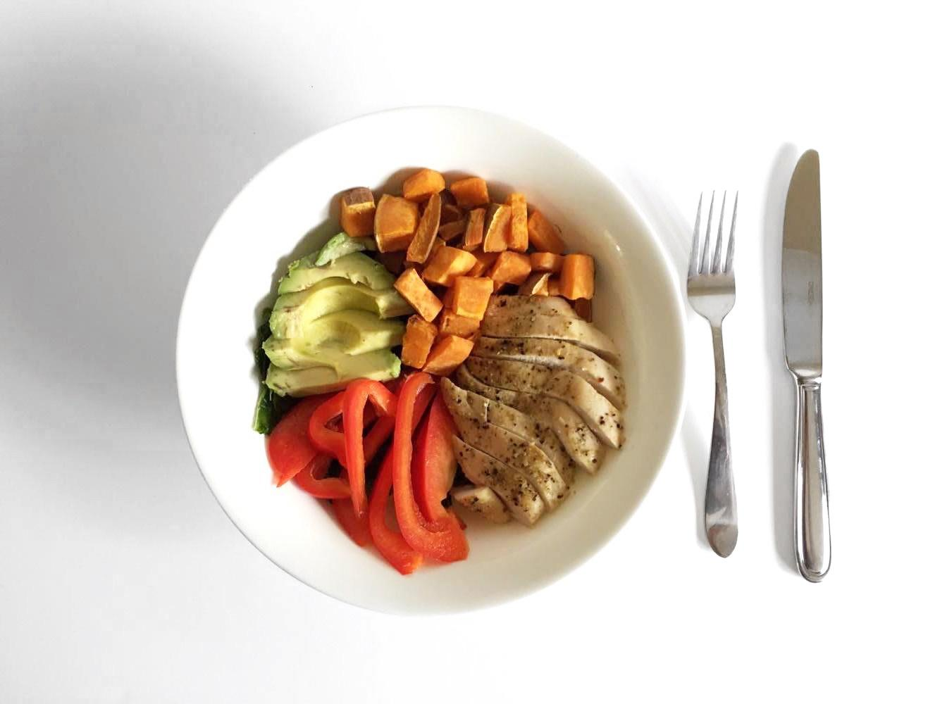
NUTRITIONAL VALUE
(per serving)
Fat: 30 g
Carbs: 45 g
Protein: 36 g
Total Calories: 574 Calories

INGREDIENTS
(2 Servings)
4 Cups of Kale
8 oz of Chicken Breast
1 Sweet Potato
1 Avocado
1 Red Bell Pepper
1 tsp Olive Oil
Dressing per Serving:
1 Tbsp of Tahini
1 Tbsp of Lemon Juice
POWER BOWL
DIRECTIONS
Preheat the oven at 350F/175C.
Place the chicken breast and cube sized sweet potatoes on a baking tray with parchment paper and bake for 30 minutes.
Meanwhile, clean and chop the kale. Once the kale is ready mix it in with the olive oil and massage it into the kale.
Chop the red peppers and avocado.
Prepare the dressing by mixing the tahini and fresh lemon juice.
Once the chicken and sweet potatoes are done, place the massaged kale at the bottom of a dish and add all of the other ingredients on top of it, finishing off with the dressing.
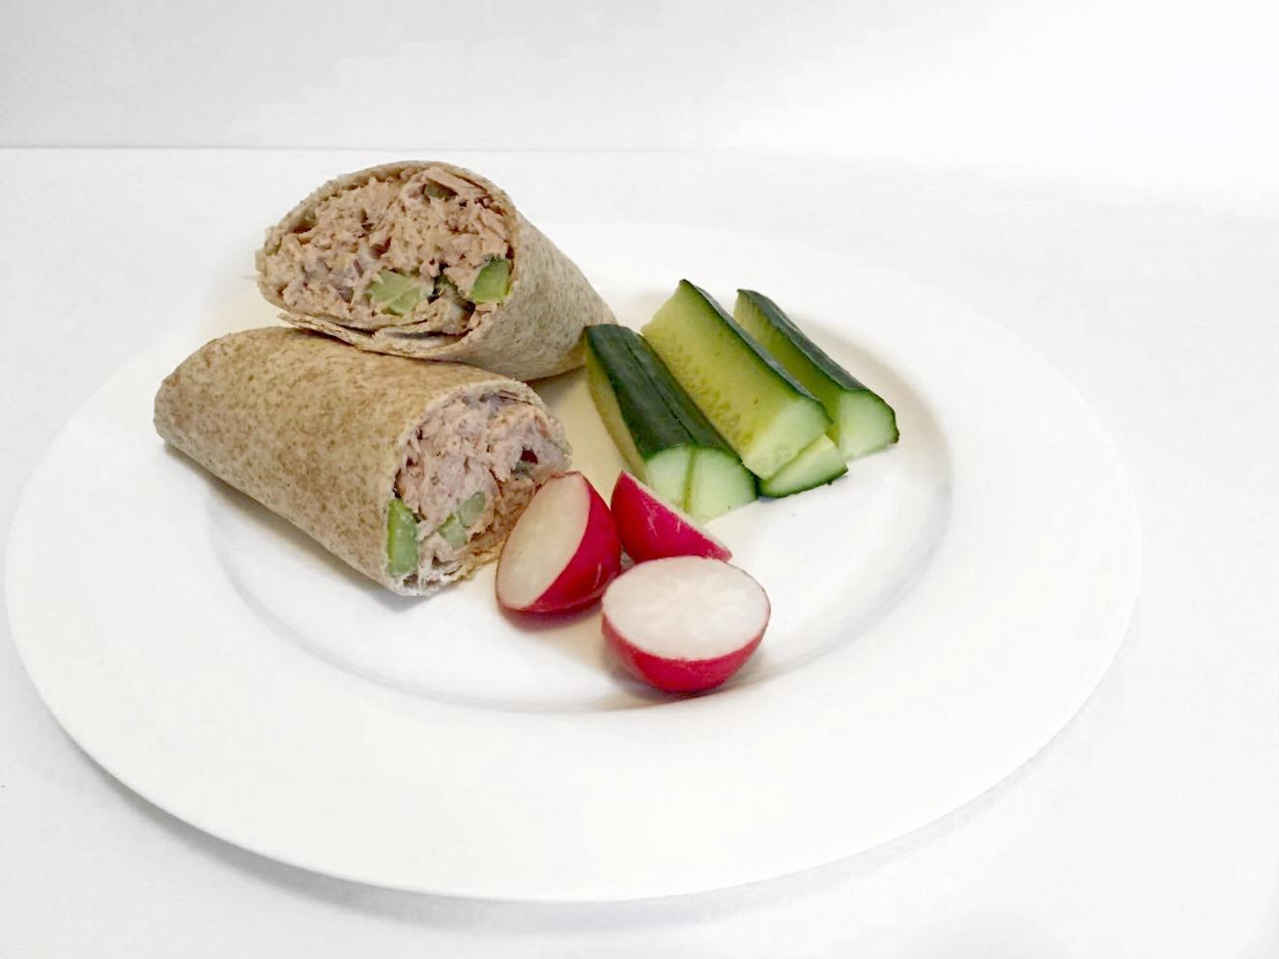
TUNA WRAP
INGREDIENTS
1 Can of Tuna
1/2 Avocado
2 Stalks of Celery
1/4 Cup of Red Onions
2 Brown Rice Tortilla Wraps
NUTRITIONAL VALUE
Fat: 17 g
Carbs: 43 g
Protein: 38 g
Total Calories: 453 Calories
DIRECTIONS
Drain the can of tuna and pour it into a mixing bowl.
Scoop out half of an avocado and mix it in with the tuna.
Finely chop the celery and red onion and add to the bowl.
Season with salt and pepper.
Add the mixture to the brown rice tortilla wraps and roll.

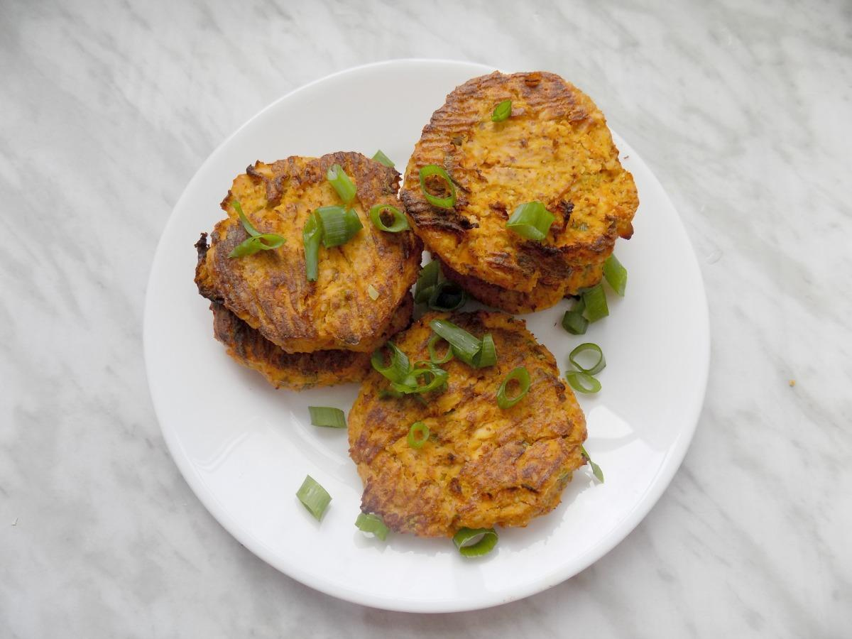
INGREDIENTS
(2 Servings)
1 Medium Sweet Potato
8 oz Salmon Filet
1 Egg
1/2 Cup of Almond Flour
1/4 Cup of Green Onions
1 tsp of Sea Salt
1/4 tsp of Black Pepper
SWEET POTATO SALMON CAKES
NUTRITIONAL VALUE
(per serving)
Fat: 25 g
Carbs: 25 g
Protein: 30 g
Total Calories: 434 Calories

DIRECTIONS
Preheat the oven at 400F/200C and line a baking sheet with parchment paper.
Wash and peel the sweet potato and steam until soft.
Bake the salmon for about 15-20 minutes.
Once the sweet potato is soft and the salmon is cooked mash them together in a bowl
Place the remaining ingredients in the bowl.
Form 8 patties and spread them out on the baking sheet.
Bake the Sweet Potato Salmon cakes for 30 minutes, flip the patties at around 15 minutes.
Serve on its own or with a green salad.
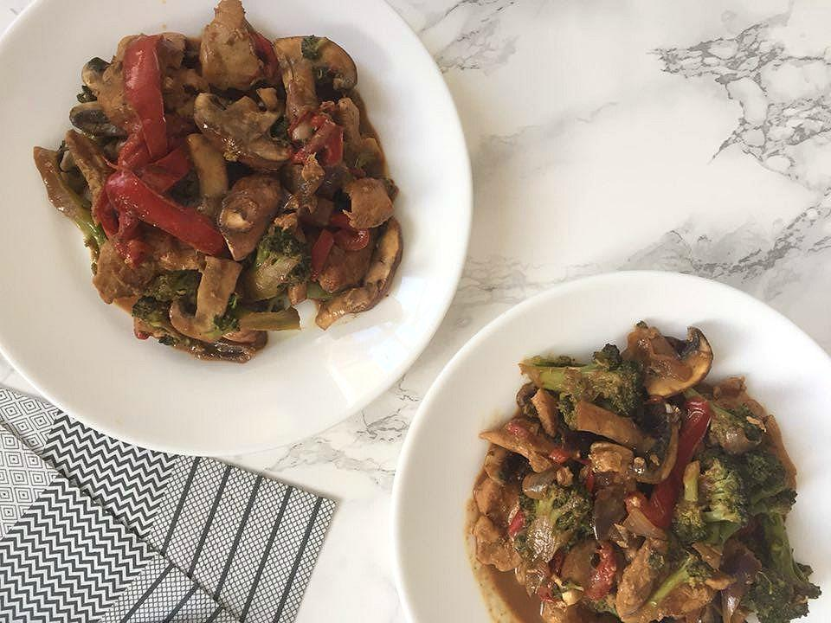
DIRECTIONS
Chop all the vegetables in bite size pieces.
Place a pan on medium heat and melt the coconut oil.
Slice the chicken and add to the pan.
Meanwhile combine the coconut aminos and almond butter and whisk until it forms a thick sauce.
Once the chicken in cooked add in all the vegetables and the almond butter sauce.
Cook and cover for another 7-10 minutes.
Turn the heat off and take the cover off and let the sauce thicken up for a few minutes before serving.
INGREDIENTS
(2 Servings)
8 oz Chicken Breast
2 Cups of Broccoli
1 Red Bell Pepper
4 Mushrooms
1/2 Cup of Red Onions
1/4 Cup of Coconut Aminos
2 Tbsp of Almond Butter
1 Tbsp of Coconut Oil
CHICKEN ALMOND BUTTER STIR FRY
NUTRITIONAL VALUE
(per serving)
Fat: 35 g
Carbs: 53 g
Protein: 32 g
Total Calories: 534 Calories

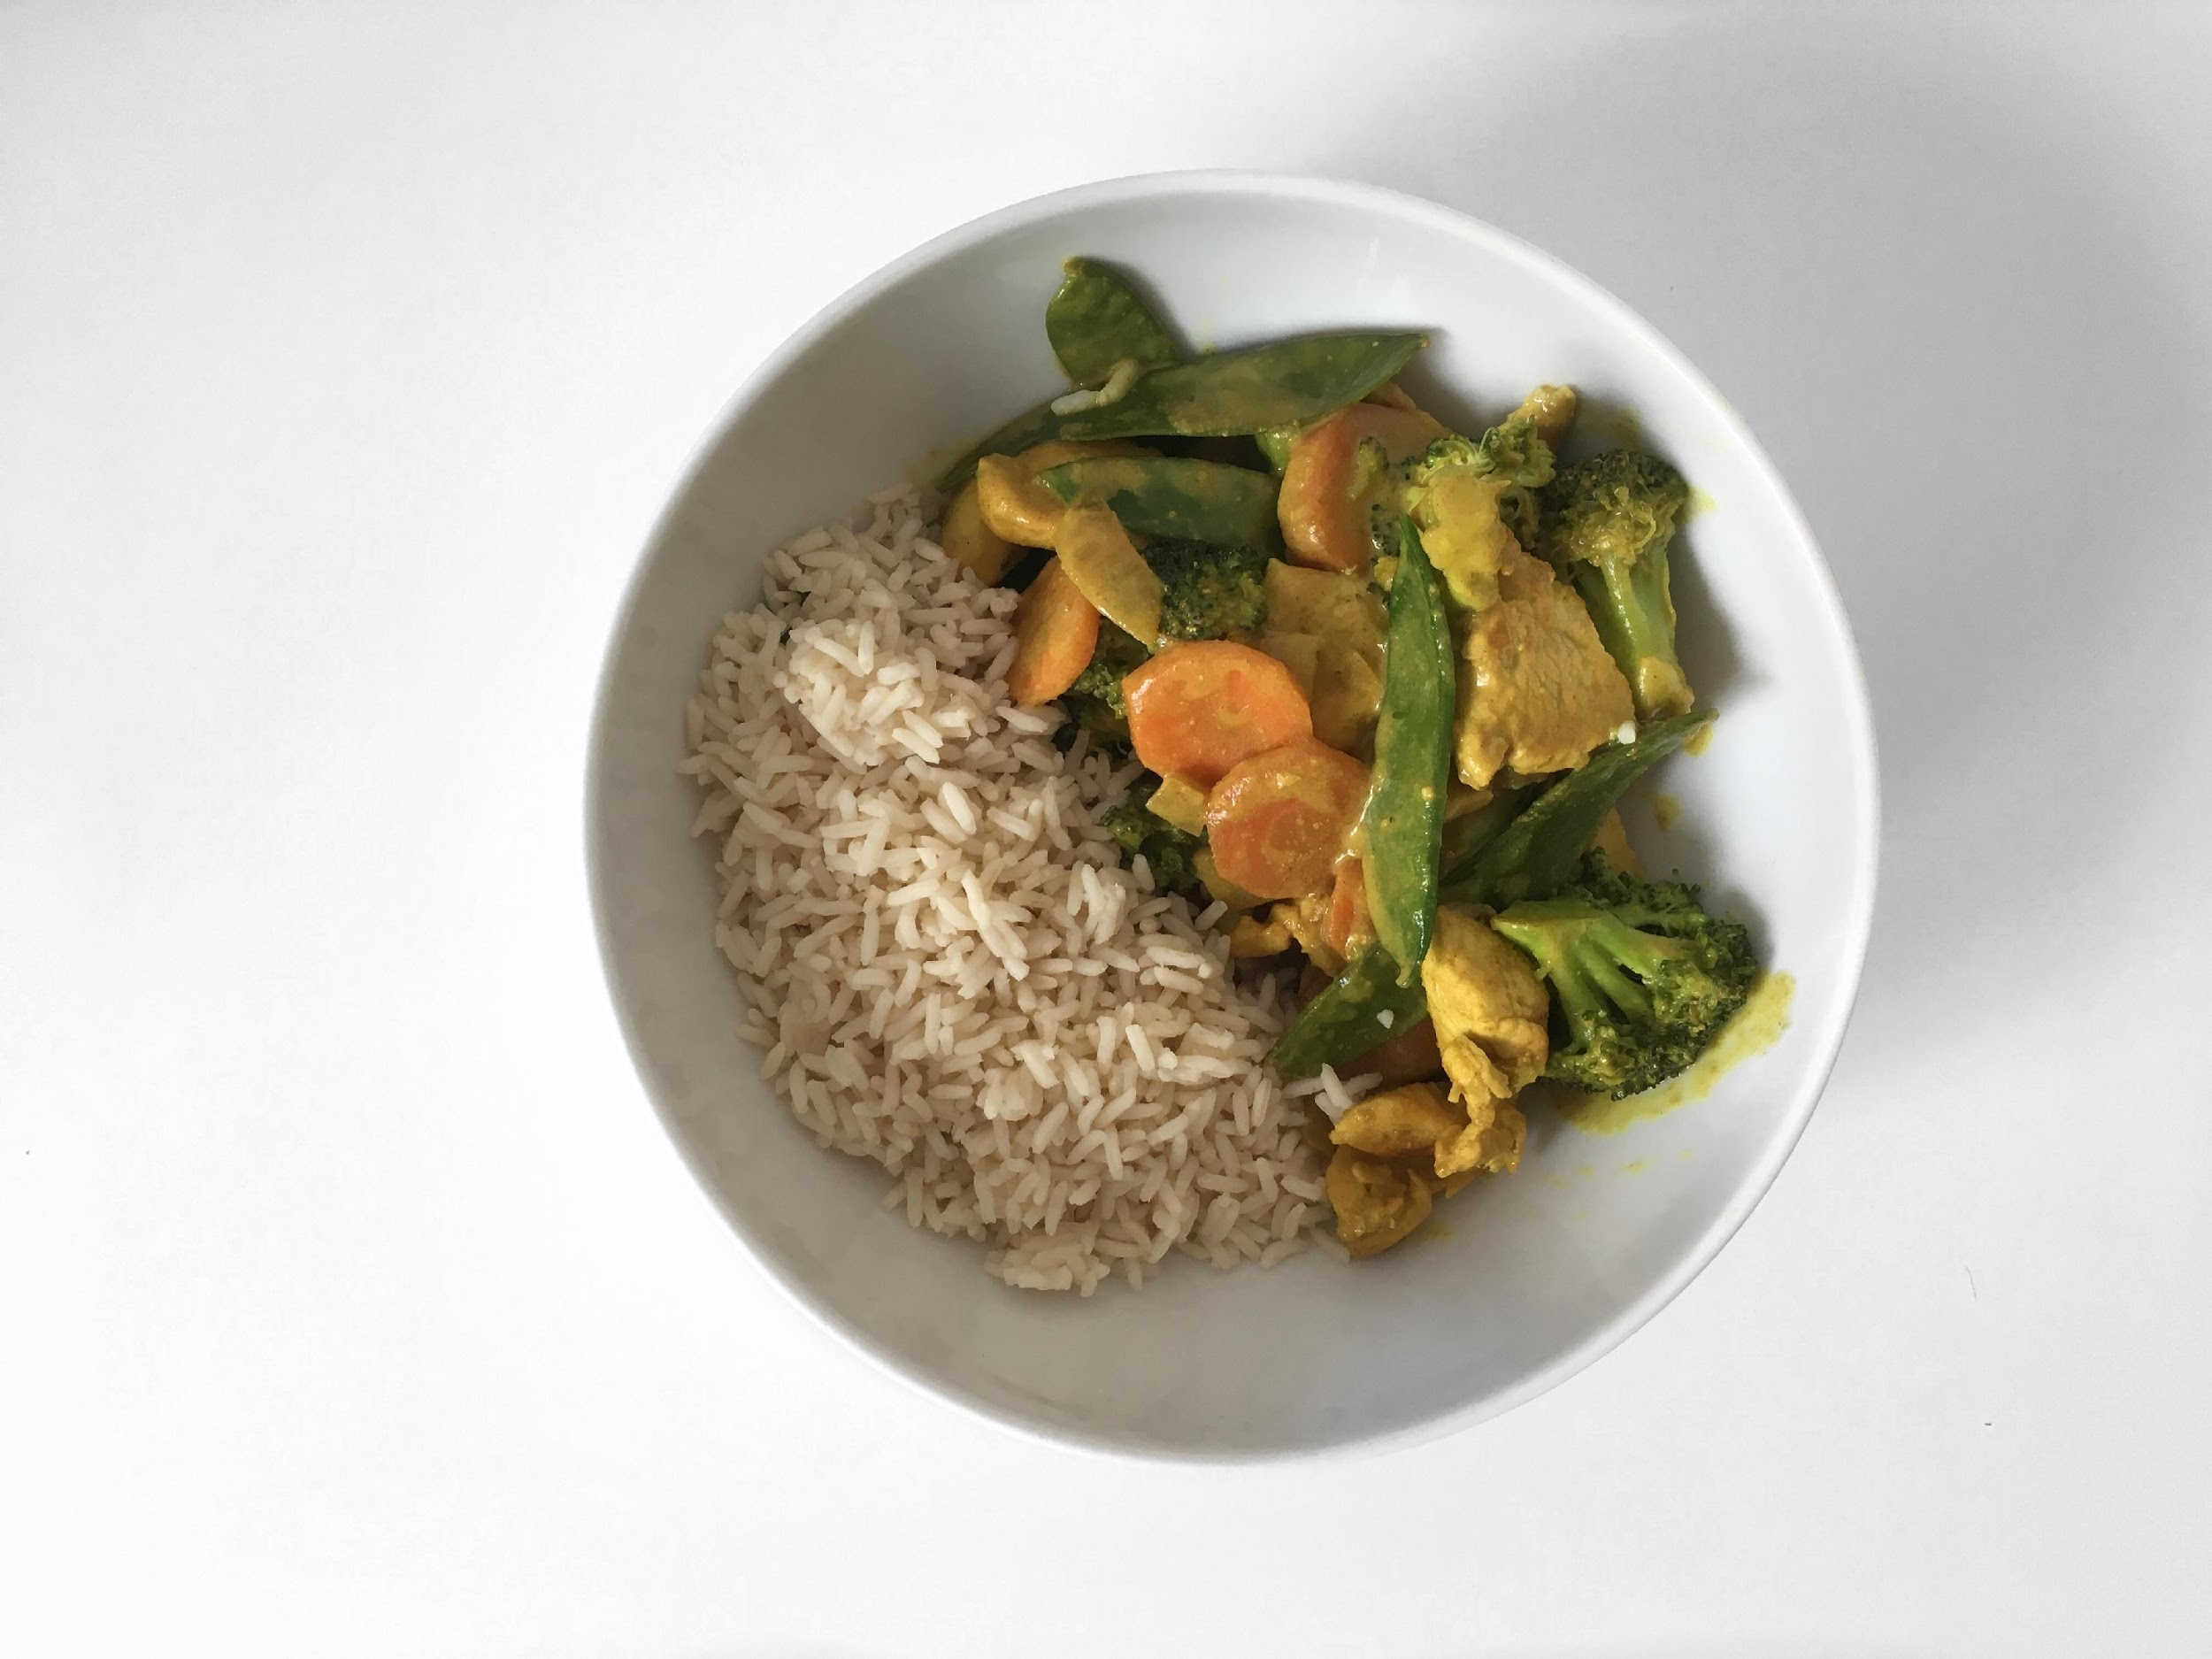
NUTRITIONAL VALUE
(1 Serving)
Fat: 50 g
Carbs: 35 g
Protein: 35 g
Total Calories: 720 Calories
INGREDIENTS
(Makes 2 Servings)
8 oz of Chicken
2 Cup of Broccoli
1 Carrot Sliced
1/2 Cup of Chopped Onions
1 Can of Coconut Milk
2 Cups of Cauliflower Rice
1 Tbsp of Ground Turmeric
1 Tbsp of Ground Cumin
1 Tbsp of Ground Ginger
DIRECTIONS
Place a pan on medium heat and melt 1 teaspoon of coconut oil.
Place the chicken in the pan and cook until it is well done.
Take the chicken out of the pan and set aside.
Add another teaspoon of the coconut oil and all the vegetables and spices to the pan. Let the vegetables sauté for 5 minutes then add the coconut milk, let it cook for another 5 minutes.
Lastly add the chicken back in and mix well.
Serve on top of cauliflower rice.
CHICKEN CURRY
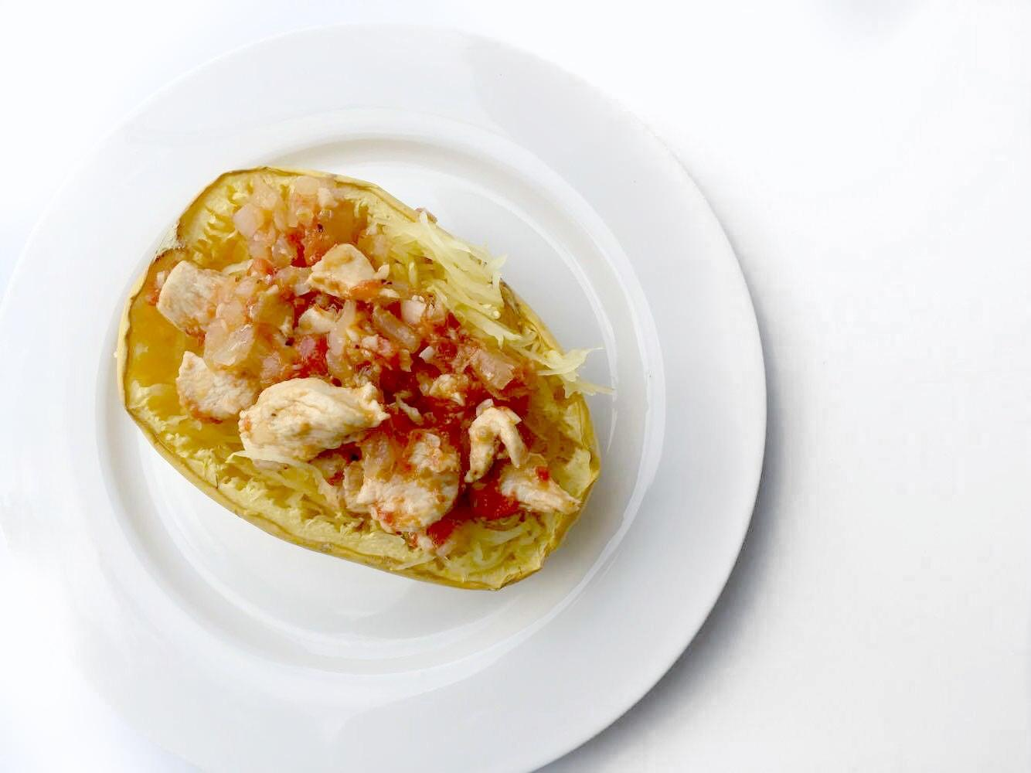
TOMATO & GARLIC SPAGHETTI SQUASH
INGREDIENTS
( 2 Servings)
1 Small Spaghetti Squash
8 oz of Chicken Breast
1 Can of Diced Tomatoes
2 Cloves of Garlic
1/4 Cup of Onions
2 Tbsp of Extra Virgin Olive Oil
NUTRITIONAL VALUE
(per serving)
Fat: 38 g
Carbs: 33 g
Protein: 27 g
Total Calories: 557 Calories

DIRECTIONS
Start by pre-heating the oven to 400F/200C.
Cut your spaghetti squash into two equal halves and take the seeds out by using a spoon. Bake the squash with the peel on the bottom of a baking tray for 45 minutes.
While the squash is cooking you can start preparing the sauce by placing a pan on low-medium heat and adding the olive oil.
Next, add the garlic, onion and diced tomatoes. Slice the chicken breasts and add them to the pan. Stir every few minutes to make sure the chicken cooks evenly.
Once the garlic and tomato sauce is ready you can set it aside on low heat and wait for the squash to be done. After 45 minutes, take the squash out and use a fork to scrape out the squash into spaghetti like strings. Top it off with the chicken garlic tomato sauce.
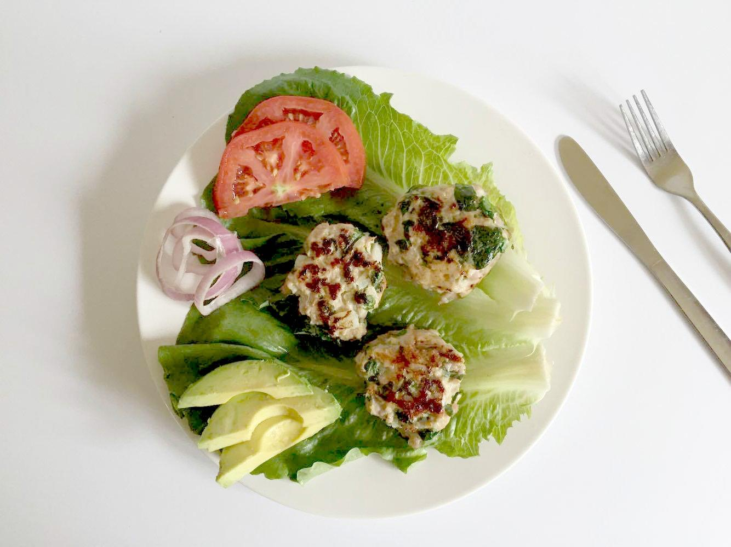
TURKEY LETTUCE BURGERS
INGREDIENTS
(2 Servings)
450 g of Ground Turkey
1 Cup of Spinach
1/4 Cup of Onions
1 Clove of Garlic
1 Tbsp of Coconut Oil
NUTRITIONAL VALUE
(per serving)
Fat: 25 g
Carbs: 3 g
Protein: 40 g
Total Calories: 405 Calories
DIRECTIONS
Chop the spinach, onions and garlic and combine in a mixing bowl with the ground turkey, salt and pepper.
Melt the coconut oil on medium heat in a pan.
Form 6 patties and fry for 3-5 minutes each side.
Once the burgers are ready add your favourite toppings on top of the patties and enjoy.
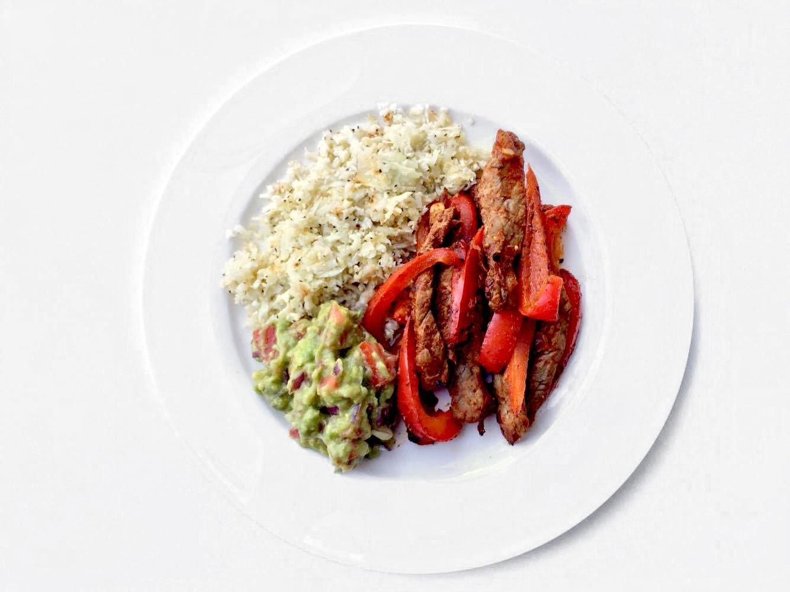
DIRECTIONS
Prepare the rice according to packaging directions.
Place a pan on medium heat and add the coconut oil. Once the oil has melted add the onions and garlic and sauté for 1 minute.
Add the beef strips and cook for 3-5 minutes.
Meanwhile cut the red pepper into strips. Once the beef is ready add the peppers and all the fajita seasoning spices and cook for an extra 5 minutes.
Combine in a bowl the beef mixture, brown rice and mashed avocado.
NUTRITIONAL VALUE
(per serving)
Fat: 10 g
Carbs: 41 g
Protein: 27 g
Total Calories: 330 Calories
INGREDIENTS
(2 Servings)
8 oz Beef Sirloin Strips
1 Red Bell Pepper
1/2 Cup of Onions
2 Cloves of Garlic
1/2 Cup of Brown Rice
1 Avocado
1 Tbsp of Coconut Oil
Fajita Seasoning:
1 Tbsp Paprika
1 tsp Garlic Powder
1 tsp Onion Powder
1/2 tsp Cayenne Powder
BEEF FAJITA BOWL
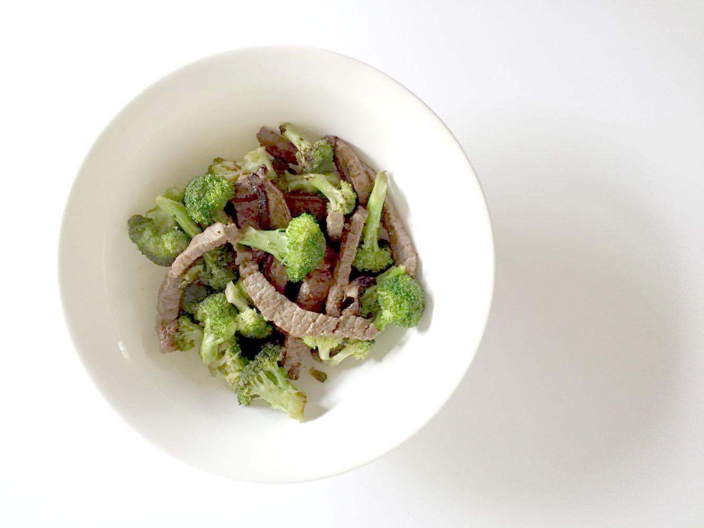
BEEF & BROCCOLI
INGREDIENTS
(2 Servings)
8 oz Beef Sirloin Strips
2 Cups of Broccoli
1/2 Cup of Brown Rice
1/4 Cup of Coconut Aminos
1/2 Cup of Onions
1 Cloves of Garlic
1 Tbsp of Coconut Oil
NUTRITIONAL VALUE
Fat: 23 g
Carbs: 52 g
Protein: 28 g
Total Calories: 454 Calories

DIRECTIONS
Start by bringing 1 cup of water with the rice to a boil. Once the water is boiling bring down to a simmer.
Next finely chop the onion and garlic. Place a large pan on medium heat and add the coconut oil, once the oil has melted add the onions and garlic.
Once the onions are translucent add the beef strips into the pan and cook for 3-5 minutes.
Lastly cut the broccoli into small floret and add them into the pan along with the coconut aminos.
Cover and cook on low heat for 10 minutes. Once the beef and broccoli is done serve it on top of the brown rice.
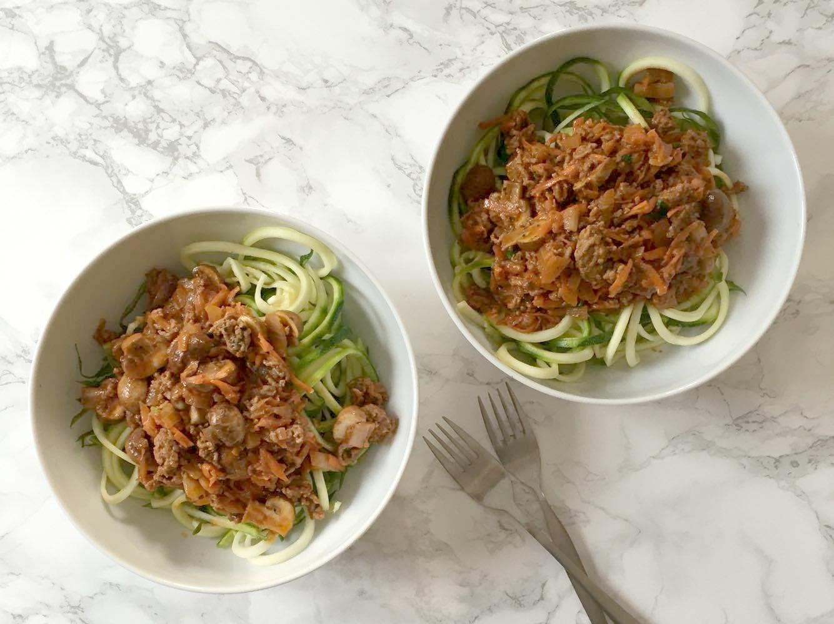
ZUCCHINI NOODLES & BOLOGNESE
INGREDIENTS
(2 Servings)
2 Zucchinis
450 g of Ground Beef
1/2 Cup of Coconut Milk
1/4 Cup of Tomato Paste
1 Cup of Spinach
1 Carrot
6 Mushrooms
1/2 Cup of Onions
2 Cloves of Garlic
1 Tbsp of Coconut Oil
NUTRITIONAL VALUE
(per serving)
Fat: 25 g
Carbs: 10 g
Protein: 28 g
Total Calories: 374 Calories
DIRECTIONS
Chop the onions, garlic and mushrooms.
In a pan melt the coconut oil and add the onions and garlic, once the onions become translucent add in the ground beef and season with salt and pepper.
Once the ground beef is cooked through, add the chopped mushrooms and spinach.
In a small bowl combine the coconut milk and tomato paste and mix together until it forms a thick sauce.
Add the coconut milk and tomato paste mixture to the skillet and turn the heat down to low, let simmer for about 10 minutes.
While the bolognese is cooking wash 1 zucchini and spiralize it into noodles.
Serve the bolognese on top of the spiralized zucchini.
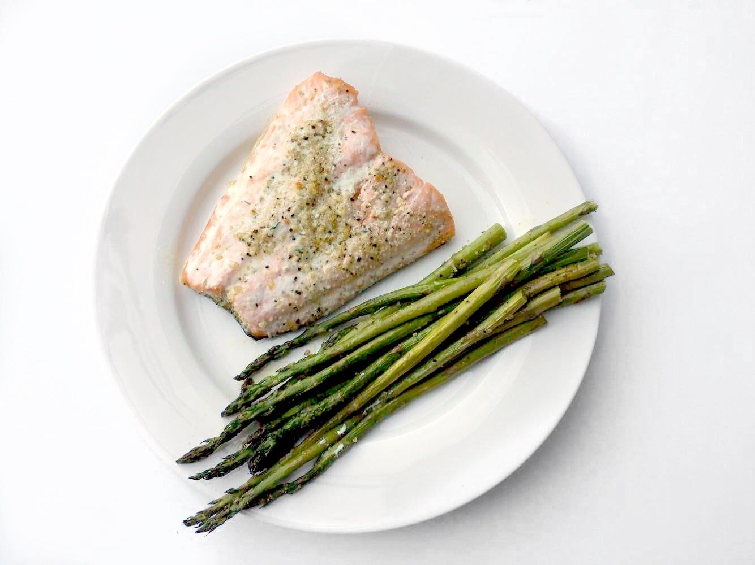
BAKED SALMON
INGREDIENTS
4 oz of Salmon Fillet
1/4 Cup of Brown Rice
10 Stalks of Asparagus
1 Tbsp of Olive Oil
NUTRITIONAL VALUE
Fat: 22 g
Carbs: 29 g
Protein: 28 g
Total Calories: 419 Calories
DIRECTIONS
Start by pre-heating the oven at 350F/175C.
Cut off the ends of the asparagus and wash it. Coat the salmon and the asparagus with olive oil, salt and pepper. Line a baking tray with parchment paper, add the salmon and asparagus to the baking tray and bake for 20 minutes.
Meanwhile prepare the rice by adding 1/2 cup of water and the rice to a pot. Bring to a boil and then turn the heat down to a simmer until all of the water is absorbed.
Plate the salmon, asparagus and brown rice together and enjoy.
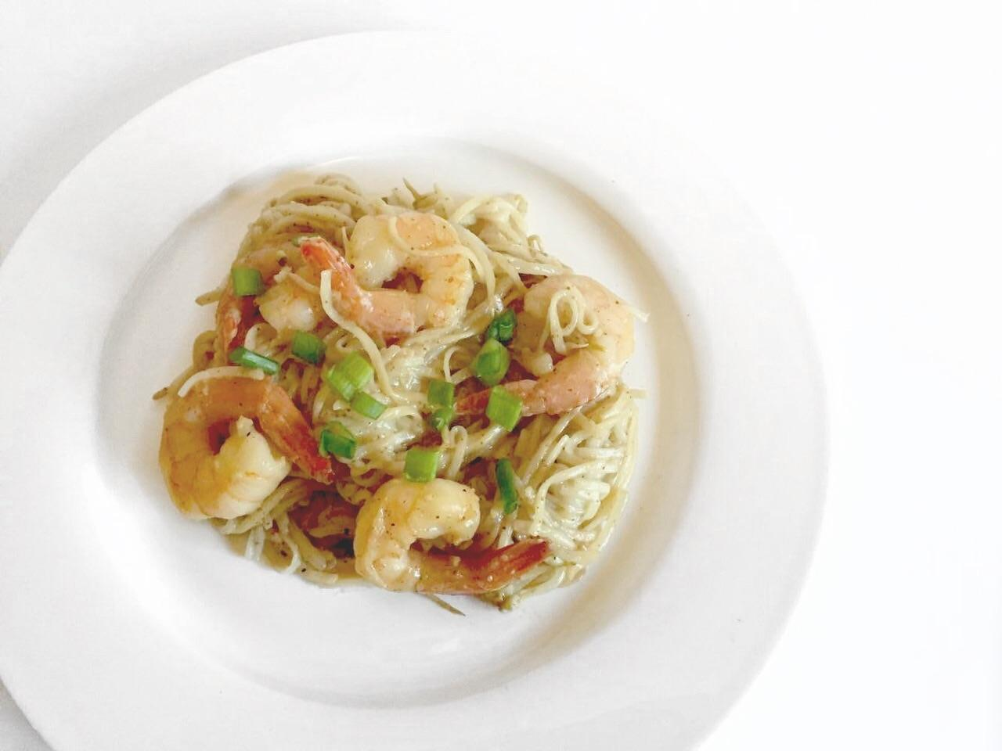
INGREDIENTS
(2 Servings)
6 oz of Brown Rice Noodles
8 oz of Shrimps
2 Cups of Bean Sprouts
2 Cloves of Garlic
1/2 Cup of Green Onions
1/4 Cup of Coconut Aminos
2 Tbsp of Almond Butter
1 Tbsp of Coconut Oil
SHRIMP PAD THAI
NUTRITIONAL VALUE
(per serving)
Fat: 26 g
Carbs: 67 g
Protein: 24 g
Total Calories: 581 Calories

DIRECTIONS
Heat up a pan on medium heat and add the coconut oil. Finely chop the garlic and add it to the pan with the shrimps.
Meanwhile fill up a pot with water and bring to a boil. Once the water is boiling add in the brown rice noodles.
Once the shrimps are ready add in the bean sprouts.
Combine the coconut aminos and the almond butter to form a thick sauce and toss it in the pan while lowering the heat.
Combine the noodles and the shrimp mixture together and enjoy.
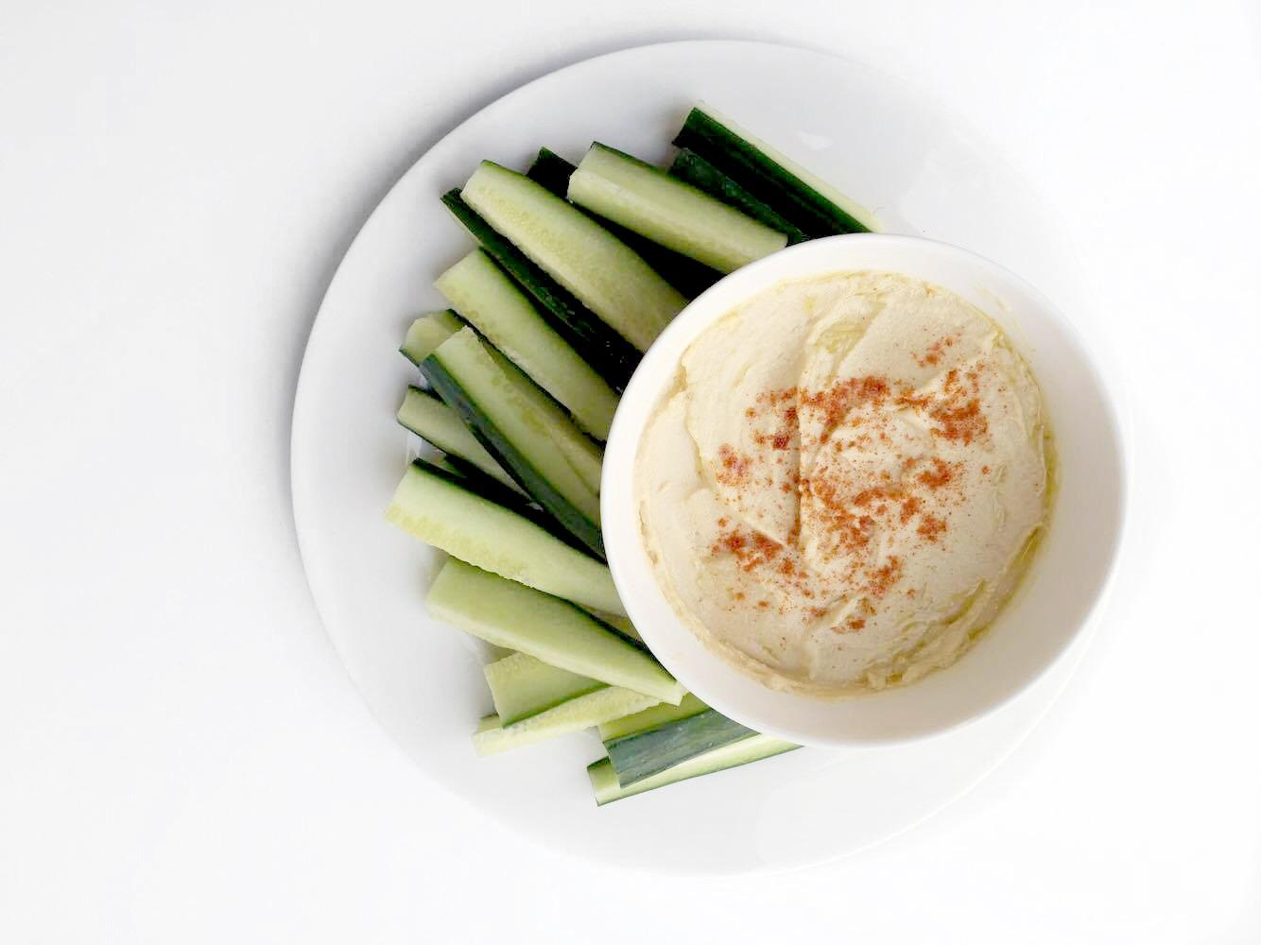
HUMMUS & VEGETABLES
INGREDIENTS
(4 servings)
1 Can of Chickpeas
1/4 Cup of Tahini
2 Tbsp of Extra Virgin Olive Oil
2 Tbsp of Lemon Juice
1 Clove of Garlic
1 tsp of Cumin
1/2 tsp of Sea Salt
1 Cup of Cucumber Sticks
NUTRITIONAL VALUE
(per serving)
Fat: 16 g
Carbs: 22 g
Protein: 8 g
Total Calories: 251 Calories
DIRECTIONS
Start by preparing the chickpeas. If you are preparing dry chickpeas follow the instructions on the packaging or if you are using canned make sure to drain the chickpeas and rinse them well.
Once the chickpeas are ready, place all of the ingredients in a food processor and process until it forms a smooth and creamy texture.
Store the hummus into an air tight container or portion it out immediately into 4 servings.
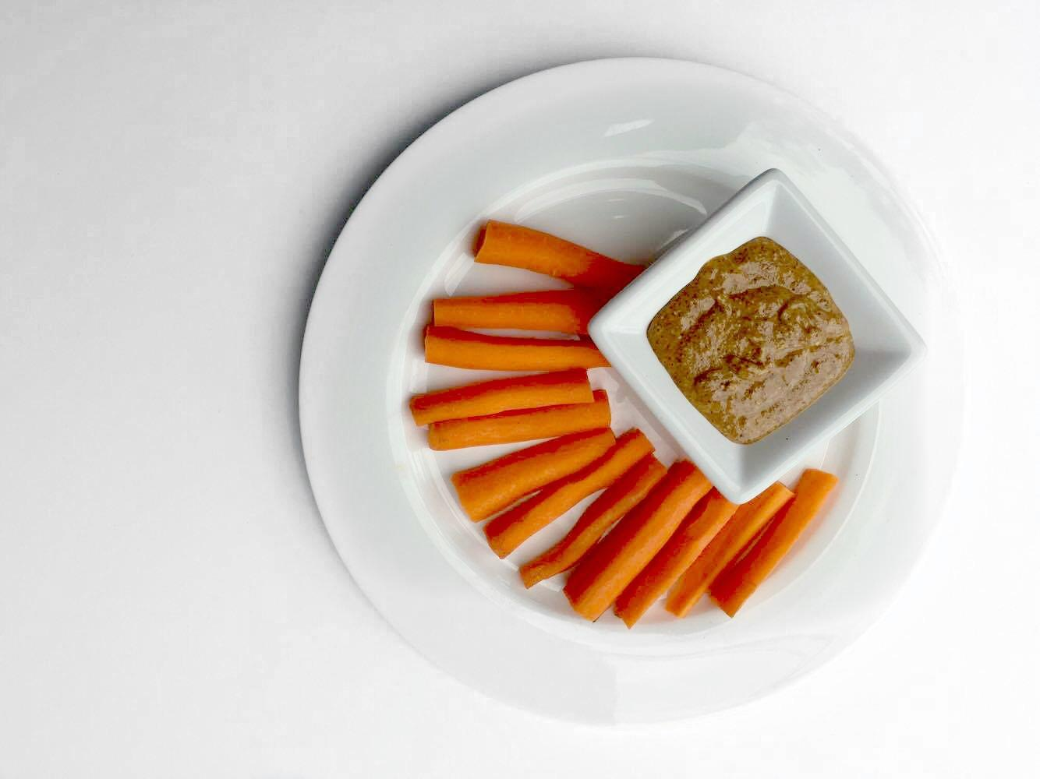
CARROTS & ALMOND BUTTER
INGREDIENTS
2 Carrots
1 Tbsp of Almond Butter
NUTRITIONAL VALUE
Fat: 19 g
Carbs: 13 g
Protein: 5 g
Total Calories: 229 Calories

DIRECTIONS
Slice the carrots into sticks and use the almond butter as a dip.
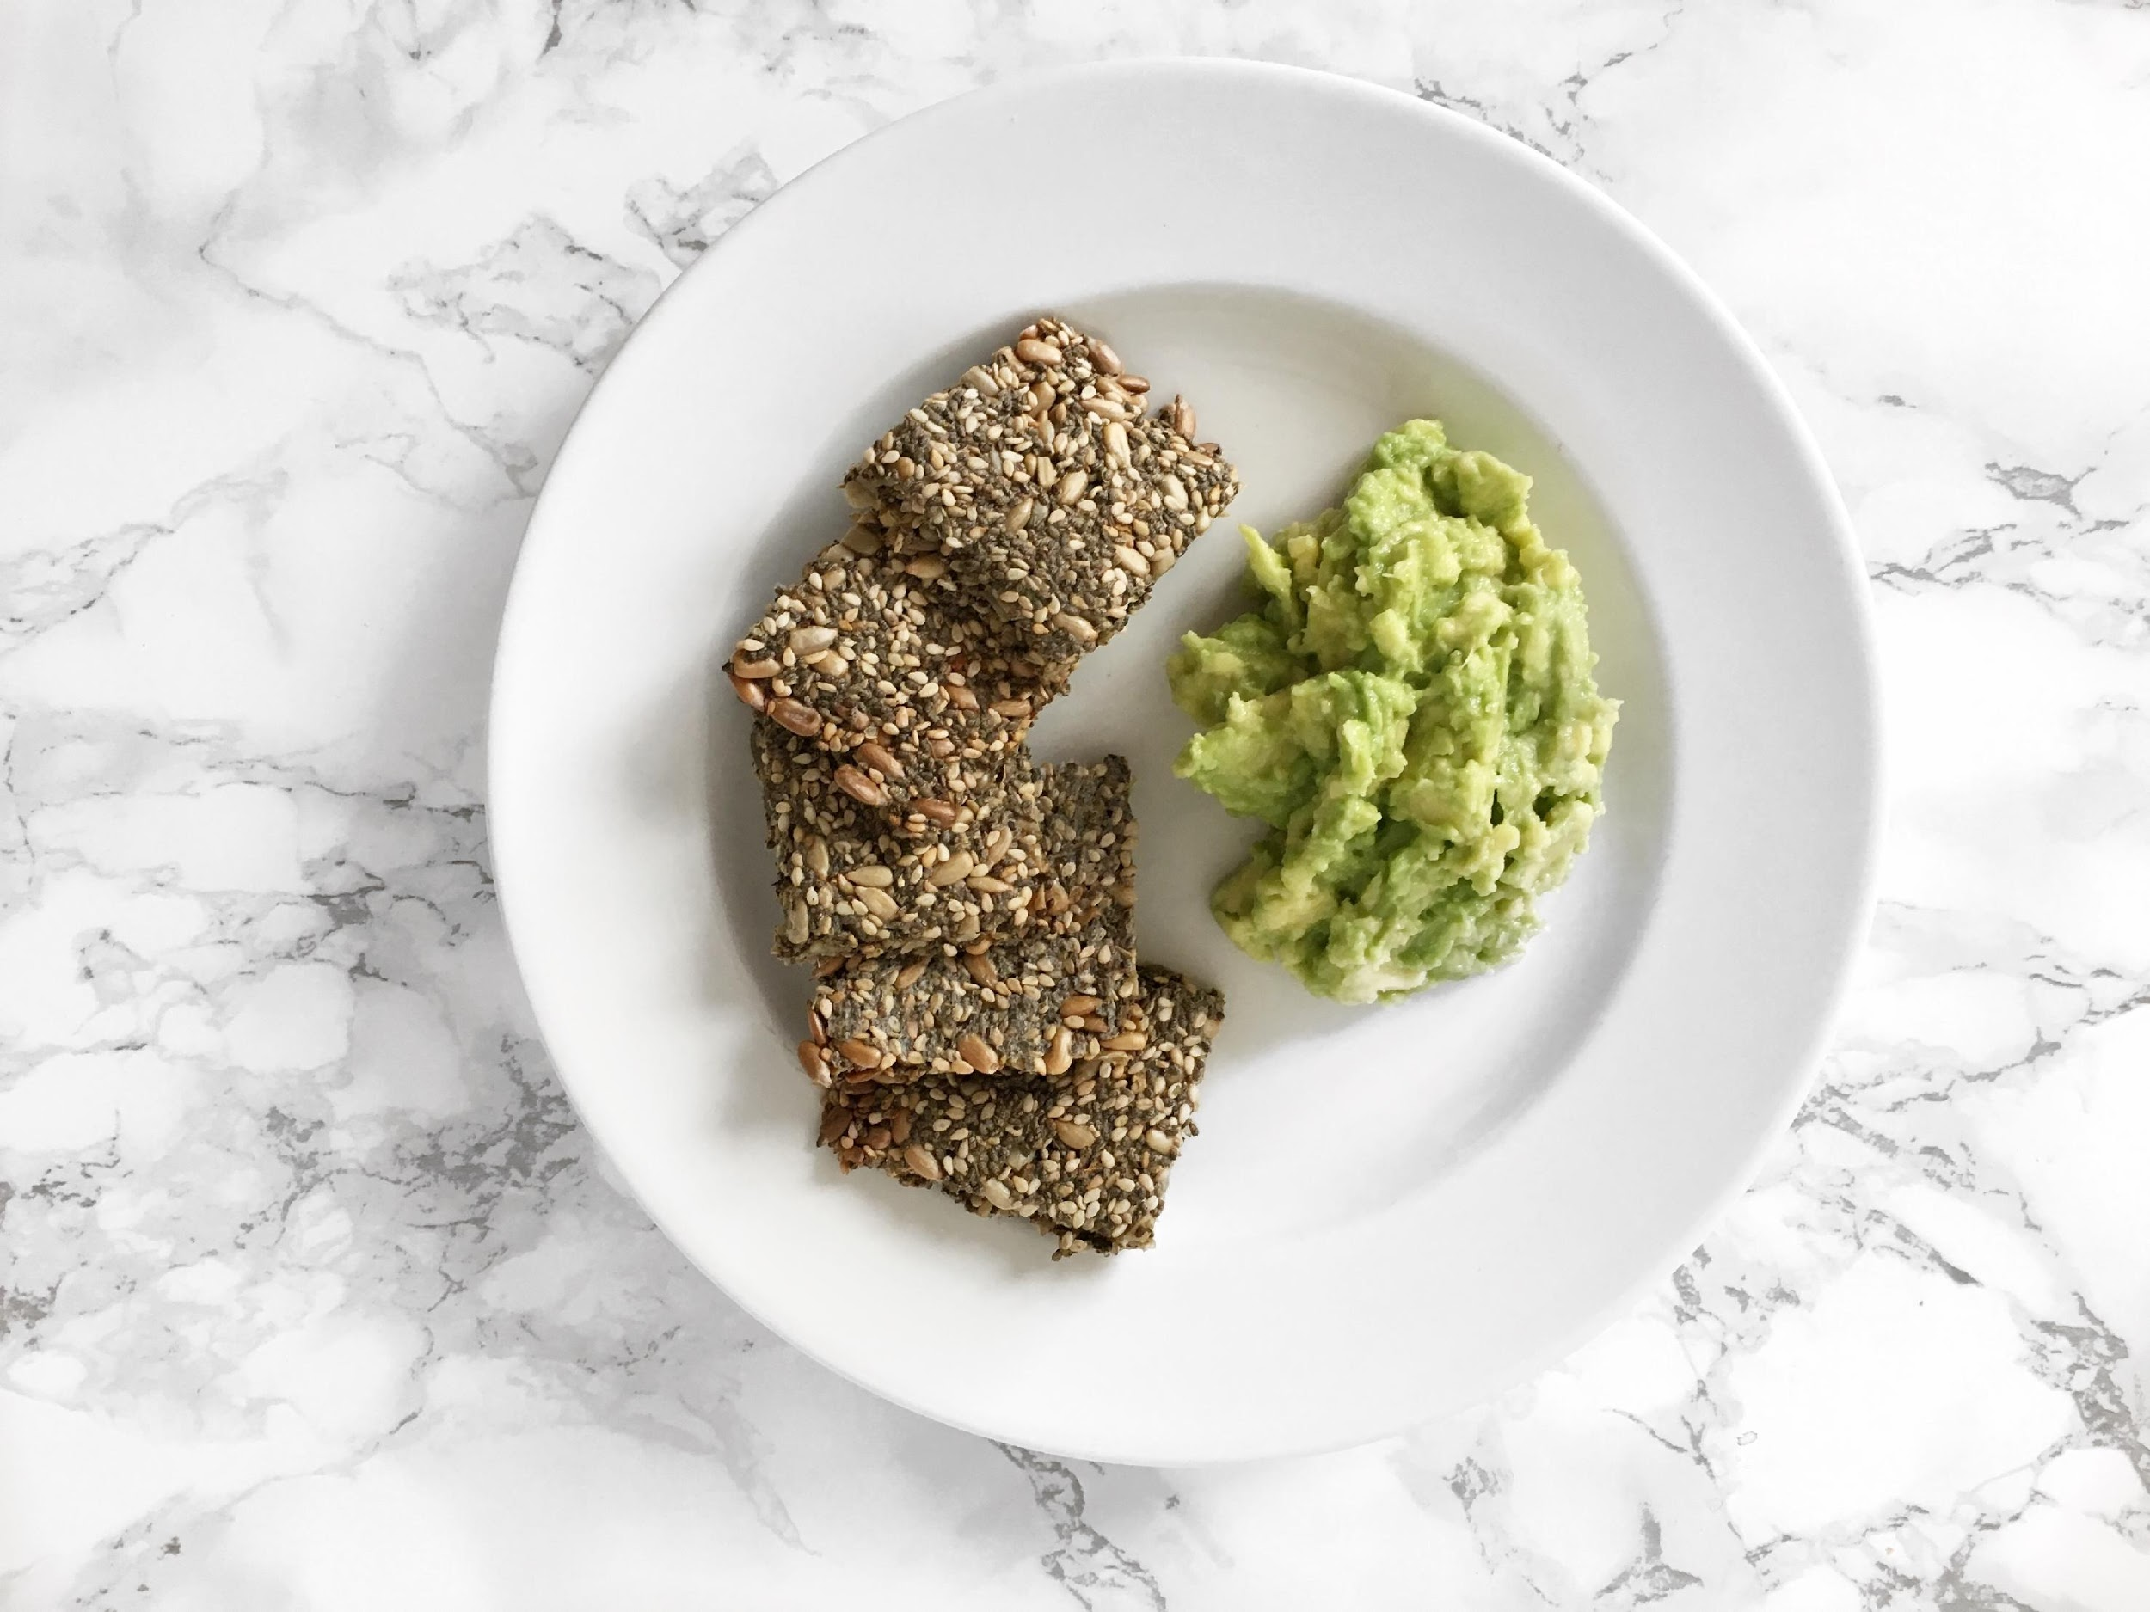
NUTRITIONAL VALUE
(per serving)
Fat: 24 g
Carbs: 14 g
Protein: 8 g
Total Calories: 280 Calories
SEED CRACKERS & GUACAMOLE
DIRECTIONS
Preheat the oven to 175C.
Combine all the seeds together with water and seasonings. Let the mixture sit for 5 minutes.
Line a baking sheet with parchment paper and spread the seed mixture evenly until flat.
Bake for 30 minutes then remove from the oven, cut them into squares, flip them and bake for another 15 minutes.
Meanwhile combine the guacamole ingredients in a bowl and mash until you have your desired consistency.
INGREDIENTS
(Makes 4 Servings)
1/4 Cup of Chia Seeds
1/4 Cups of Sesame Seeds
1/4 Cups of Sunflower Seeds
1/2 Tbsp of Herb Mix Seasoning
1/2 tsp of Sea Salt
1 Cup of Water
Guacamole:
1/2 Mashed Avocado
Juice of Half a Lime
Pinch of Sea Salt
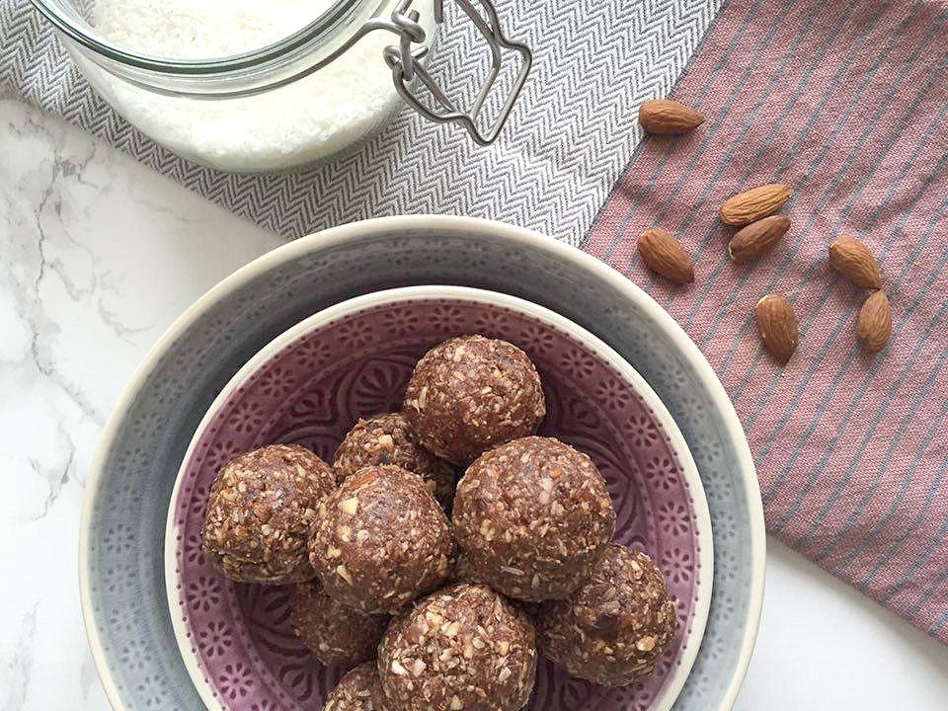
CACAO COCONUT BALLS
INGREDIENTS
(Makes 10 Balls)
1 Cup of Almonds
1/2 Cup of Shredded Coconut
8 Medjool Dates
2 Tbsp of Raw Cacao Powder
NUTRITIONAL VALUE
(2 balls)
Fat: 18 g
Carbs: 36 g
Protein: 6 g
Total Calories: 324 Calories
DIRECTIONS
Remove the pit from the dates. Combine all the ingredients in a food processor and mix until it forms a doughy mixture.
Form 10 balls with the mixture and then store them into the fridge to preserve freshness.
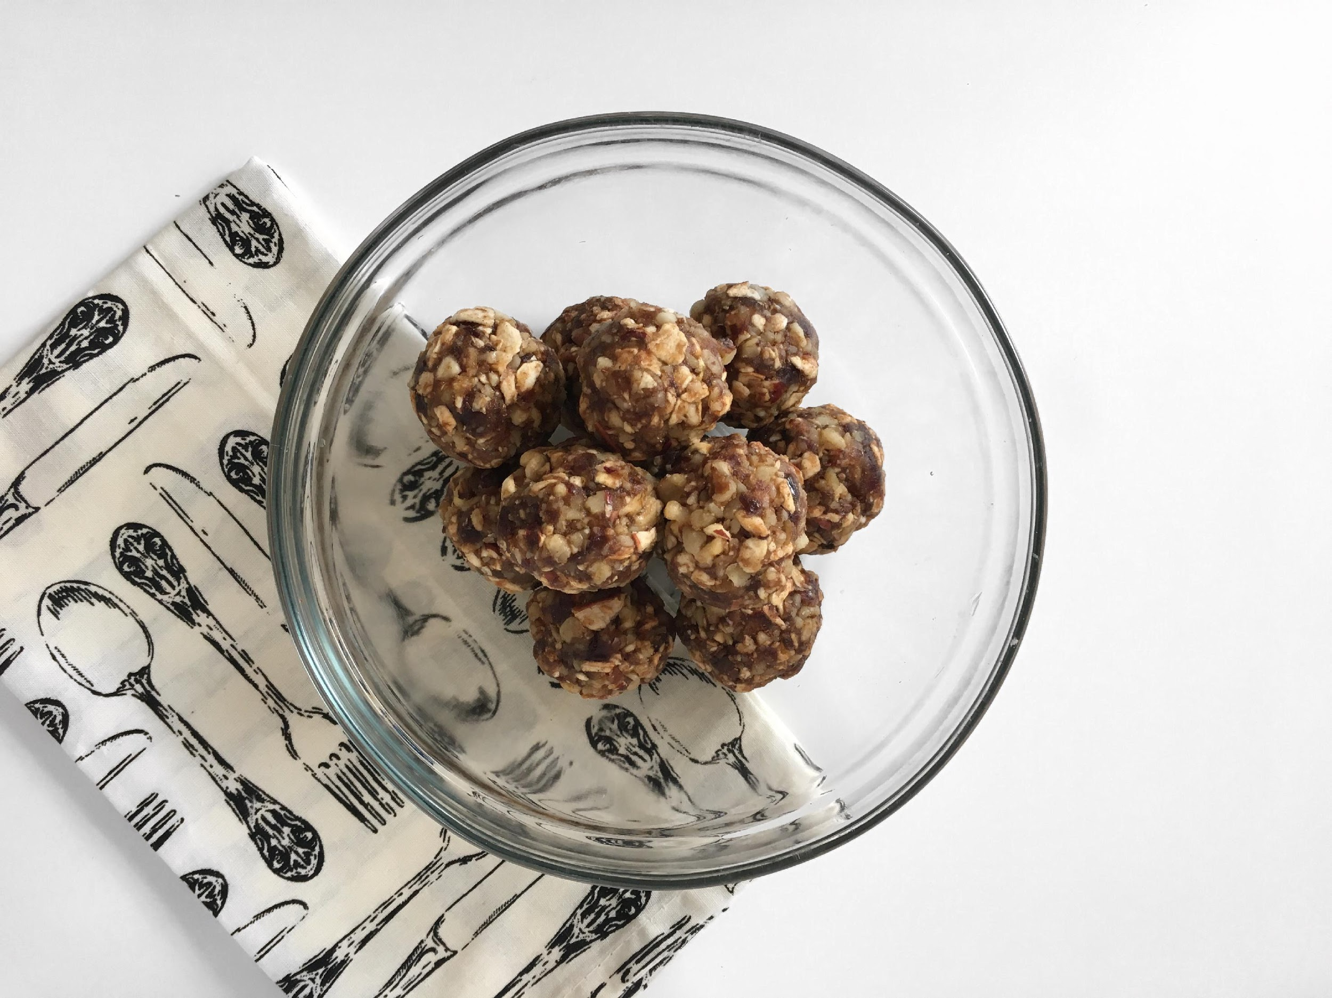
INGREDIENTS
(10 balls)
8 Medjool Dates
1 Cup of Dried Apples
1 Cup of Walnuts
1 tsp of Cinnamon
NUTRITIONAL VALUE
(2 Balls)
Fat: 16 g
Carbs: 44 g
Protein: 5 g
Total Calories: 314 Calories

DIRECTIONS
Remove the pit from the dates. Combine all the ingredients in a food processor and mix until it forms a doughy mixture.
Form 10 balls with the mixture and then store them into the fridge to preserve freshness.
APPLE PIE BITES
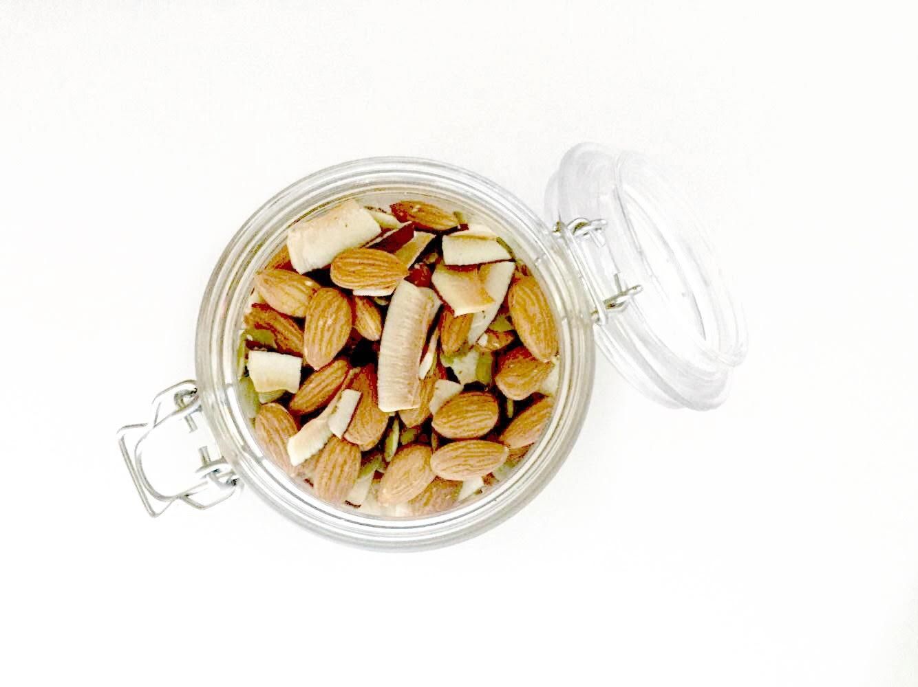
EASY TRAIL MIX
INGREDIENTS
(3 servings)
1/2 Cup of Coconut Chips
1/4 Cup of Almonds
1/4 Cup of Pumpkin Seeds
NUTRITIONAL VALUE
(per serving)
Fat: 20 g
Carbs: 9 g
Protein: 10 g
Total Calories: 256 Calories

DIRECTIONS
1. Place all of the ingredients in an air tight jar and store somewhere cool or immediately divide the trail mix into 3 portions.
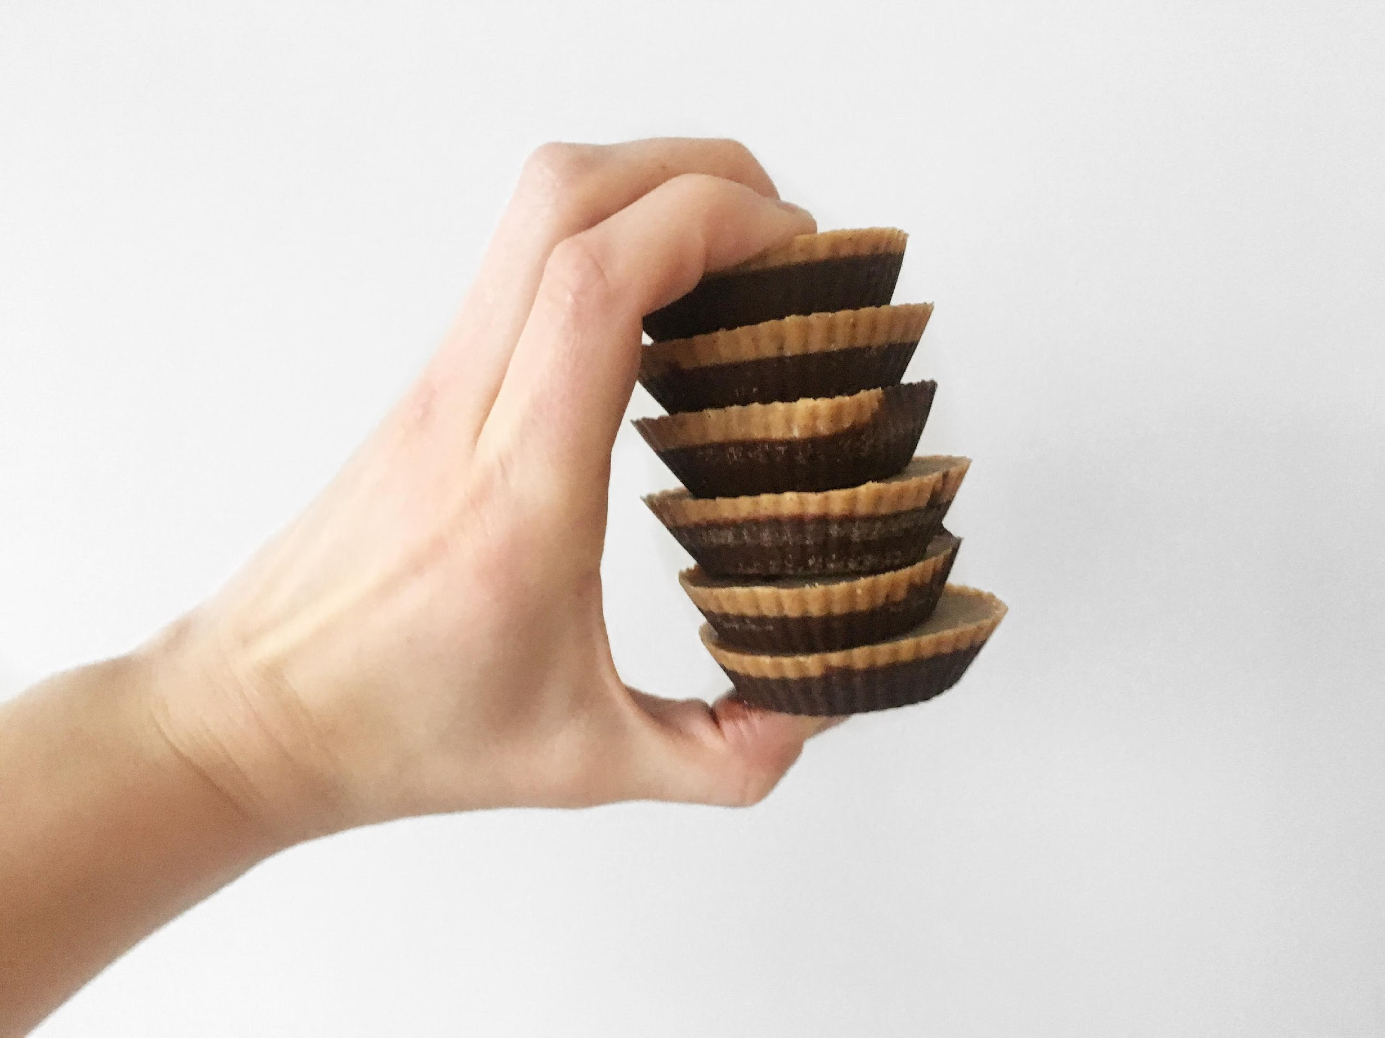
PEANUT BUTTER CUPS
INGREDIENTS
1 Tbsp of Almond Butter
1/2 Tbsp of Coconut Oil
1/4 Tbsp of Cocoa Powder
1 Drop of Vanilla Extract
NUTRITIONAL VALUE
Fat: 17 g
Carbs: 5 g
Net Carbs: 2 g
Protein: 4 g
Total Calories: 175 Calories
DIRECTIONS
Combine 1/2 Tbsp of Almond Butter, 1/4 Tbsp of Coconut Oil and 1/4 Tbsp of Cocoa Powder into a small bowl and stir until well combined.
Place the mixture is a silicon muffin cup. Freeze for 15 minutes.
Combine the rest of the ingredients in a bowl, and combine until smooth.
Once the chocolate mixture is frozen, add the almond butter mixture on top and freeze for another 15 minutes.
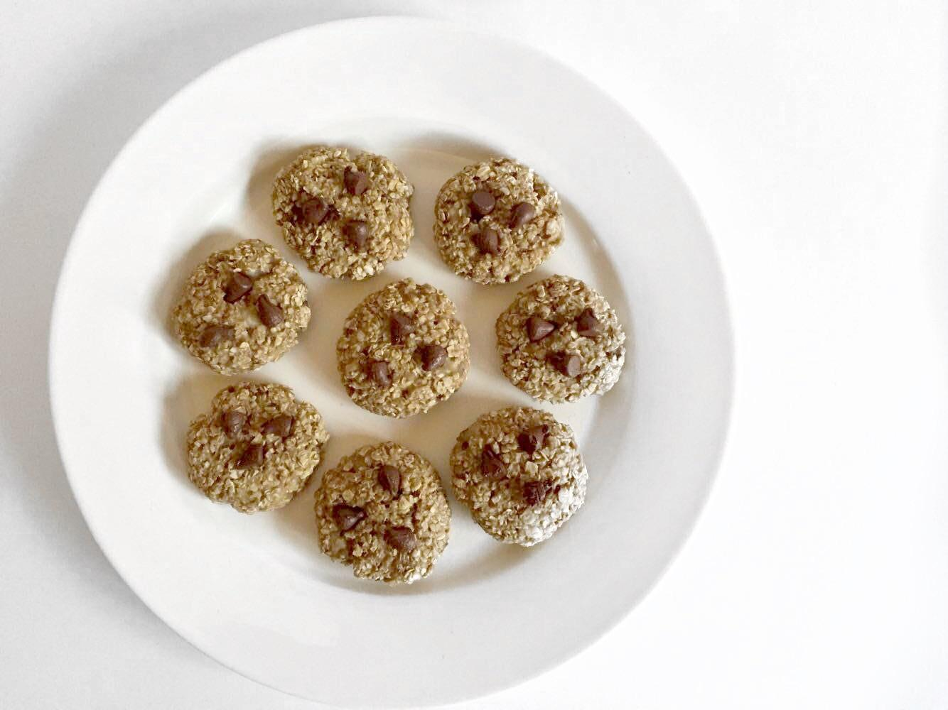
OATMEAL COOKIES
INGREDIENTS
(8 Cookies)
1 Cup of Gluten Free Oatmeal
1 Ripe Banana
1 tsp of Cinnamon
Optional: Add nuts, dried fruit or chocolate chips to customize the cookies to your liking.
NUTRITIONAL VALUE
(per cookie)
Fat: 1 g
Carbs: 19 g
Protein: 3 g
Total Calories: 99 Calories

DIRECTIONS
Preheat the oven at 375F/200C.
In a bowl, mash the banana and add the oats, cinnamon and any additional ingredients if you choose.
Combine until it forms a sticky and even mixture.
Divide the mixture in 8 equal cookies and place them on a baking sheet. Bake for 8 minutes.

28 DAY
CLEAN EATING
MEAL PLAN

Week 1
Breakfast | Green  Protein  Smoothie | Superfood Oatmeal | Green  Protein  Smoothie | Superfood Oatmeal | Green  Protein  Smoothie | Superfood Oatmeal | Banana  Pancakes
Lunch | Tuna Wraps | Power Bowl (leftovers) | Sweet Potato Salmon Cakes (leftovers) | Beef Fajita Bowl (leftovers) | Chicken Cobb  Salad  (leftovers) | Baked Salmon | Chicken Curry (leftovers)
Dinner | Power Bowl | Sweet Potato Salmon Cakes | Beef Fajita Bowl | Chicken Cobb  Salad | Eat Out Using the Clean Eating Guide Guidelines | Chicken Curry | Tomato Garlic Spaghetti Squash
Snack | Hummus & Cucumber Sticks | Cacao Coconut  Balls | Hummus & Cucumber Sticks | Cacao Coconut  Balls | Hummus & Cucumber Sticks | Cacao Coconut  Balls | Hummus & Cucumber Sticks

Week 2
Breakfast | Raspberry Coconut Smoothie | Chocolate Overnight Oats | Raspberry Coconut Smoothie | Chocolate Overnight Oats | Raspberry Coconut Smoothie | Chocolate Overnight Oats | Banana  Pancakes
Lunch | Tomato Garlic Spaghetti Squash (leftovers) | Chicken Quinoa Avocado Salad (leftovers) | Zucchini Noodles & Bolognese (leftovers) | Chicken Almond Butter Stir Fry (leftovers) | Turkey Lettuce Burgers (leftovers) | Crunchy  Kale  Salad | Shrimp Pad Thai (leftovers)
Dinner | Chicken Quinoa Avocado Salad | Zucchini Noodles & Bolognese | Chicken Almond Butter Stir Fry | Turkey Lettuce Burgers | Eat Out Using the Clean Eating Guide Guidelines | Shrimp Pad Thai | Beef & Broccoli
Snack | Seed Crackers & Guacamole | Carrots & Almond Butter | Seed Crackers & Guacamole | Carrots & Almond Butter | Seed Crackers & Guacamole | Carrots & Almond Butter | Seed Crackers & Guacamole

Week 3
Breakfast | Chocolate Banana Smoothie | Veggie Scramble & Avocado | Chocolate Banana Smoothie | Veggie Scramble & Avocado | Chocolate Banana Smoothie | Veggie Scramble & Avocado | Banana  Pancakes
Lunch | Tuna Wraps | Power Bowl (leftovers) | Sweet Potato Salmon Cakes (leftovers) | Beef Fajita Bowl (leftovers) | Chicken Cobb  Salad  (leftovers) | Baked Salmon | Chicken Curry (leftovers)
Dinner | Power Bowl | Sweet Potato Salmon Cakes | Beef Fajita Bowl | Chicken Cobb  Salad | Eat Out Using the Clean Eating Guide Guidelines | Chicken Curry | Tomato Garlic Spaghetti Squash
Snack | Apple Pie Bites | Peanut Butter Cups | Apple Pie Bites | Peanut Butter Cups | Apple Pie Bites | Peanut Butter Cups | Apple Pie Bites

Week 4
Breakfast | Blueberry Smoothie | Mini Omelettes | Blueberry Smoothie | Mini Omelettes | Blueberry Smoothie | Mini Omelettes | Banana  Pancakes
Lunch | Tomato Garlic Spaghetti Squash (leftovers) | Chicken Quinoa Avocado Salad (leftovers) | Zucchini Noodles & Bolognese (leftovers) | Chicken Almond Butter Stir Fry (leftovers) | Turkey Lettuce Burgers (leftovers) | Crunchy  Kale  Salad | Shrimp Pad Thai (leftovers)
Dinner | Chicken Quinoa Avocado Salad | Zucchini Noodles & Bolognese | Chicken Almond Butter Stir Fry | Turkey Lettuce Burgers | Eat Out Using the Clean Eating Guide Guidelines | Shrimp Pad Thai | Beef & Broccoli
Snack | Oatmeal Cookies | Easy Trail Mix | Oatmeal Cookies | Easy Trail Mix | Oatmeal Cookies | Easy Trail Mix | Oatmeal Cookies

THE
CLEAN EATING
GROCERY LISTS

1. Ingredients like coconut oil and olive oil are only on the first week’s grocery list because they are used daily so be aware if you run out you will need to re-purchase these.

2. Ingredients like Almond Butter, Coconut Aminos, Tahini, Almond Flour, Chia Seeds, Oats, Quinoa, and baking ingredients are listed in the grocery lists usually as a few tablespoons but it is recommended to buy these in bulk.

3. The vegetables are sometimes rounded off, for example when you need two cups of broccoli in a recipe you will only be able to purchase a full head. In this case I encourage you to use the extra vegetables in other meals or use it as dipping vegetables if hummus is your planned snack for the week.

4. There are also recipes with protein powder as an ingredient. Protein powders can be bought by the serving or in a big container. I recommend going to the container if it is something you plan on using past the 28 Day Meal Plan. If not then finding single servings may be best.

5. Bananas! There are always bananas needed in smoothies every week so if you buy too many or they are on sale feel free to stock up and freeze them.

6. Many of these recipes call for fresh herbs like parsley and basil. To save money, it is recommended to get these two herbs as a small plant. They are very easy to maintain and very affordable.

7. Use any excess vegetables to snack on during the week when you are hungry.

8. Lastly, always check the fridge and pantry before you head out to the grocery store with your list to make sure there are no left overs.
GROCERY TIPS & TRICKS
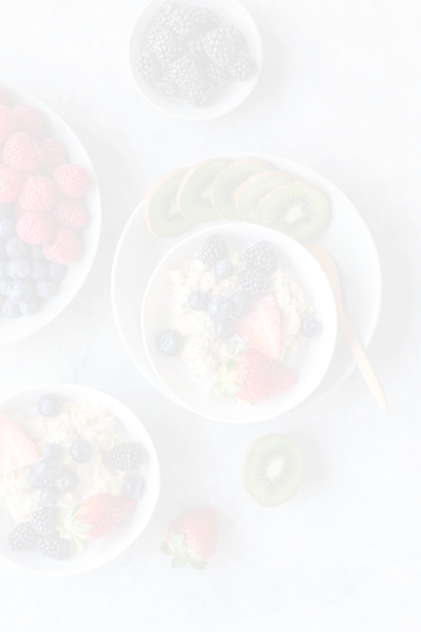
Fruits & Vegetables
3 Bananas
2 1/2 Cup of Berries
5 Avocados
1 Lemon
4 Cups of Kale
7 Cups of Spinach
2 Sweet Potatoes
1 Small Spaghetti Squash
2 Red Bell Peppers
1 Small Head of Broccoli
1 Small Head of Cauliflower
1 Carrot
10 Stalks of Asparagus
1 Cucumber
2 Stalks of Celery
1/4 Cup of Green Onions
1 Red Onion
3 Onions
5 Cloves of Garlic

Meat, Eggs & Seafood
32 oz of Chicken Breast
5 Egg
4 Slices of Bacon
8 oz Beef Sirloin Strips
12 oz Salmon Filet
1 Can of Tuna

Grains, Beans & Legumes
1 1/2 Cup of Gluten Free Oatmeal
2 Brown Rice Tortilla Wraps
3/4 Cup of Brown Rice
1 Can of Chickpeas

Nuts & Seeds
1 3/4 Cups of Almonds
3 Tbsp of Chia Seeds

Baking Supplies
1/2 Cup of Almond Flour
1/2 Cup of Shredded Coconut
8 Medjool Dates
2 Tbsp of Raw Cacao Powder
1 Tbsp of Maple Syrup

Condiments
Organic Coconut Oil
Extra Virgin Olive Oil
6 Cups of Almond Milk
1 Can of Coconut Milk
1 Can of Diced Tomatoes
1/4 Cup + 1 Tbsp of Tahini

Herbs & Spices
Sea Salt
Ground Black Pepper
Ground Cinnamon
Ground Paprika
Garlic Powder
Onion Powder
Cayenne Powder
Ground Turmeric
Ground Cumin
Ground Ginger

Extra
3 Servings of Vanilla Protein Powder
GROCERY LIST - WEEK 1
Fruits & Vegetables
2 Bananas
3 Cups of Raspberries
1 Cup of Berries
4 Avocados
2 Limes
1 Lemon
2 Cups of Kale
2 Cups of Spinach
4 Cups of Broccoli
2 Zucchinis
1 Red Bell Pepper
8 Carrots
1 Cucumber
1 Tomato
10 Mushrooms
2 Cups of Bean Sprouts
1/2 Cup of Green Onions
1 Red Onion
3 Onions
4 Cloves of Garlic

Meat, Eggs & Seafood
16 oz of Chicken Breast
450 g of Ground Turkey
8 oz Beef Sirloin Strips
450 g of Ground Beef
8 oz of Shrimps

Grains, Beans & Legumes
1 1/2 Cup of Gluten Free Oatmeal
12 oz of Brown Rice Noodles
1/2 Cup of Brown Rice
1/2 Cup of Quinoa
1/2 Cup of Chickpeas
Nuts & Seeds
1/2 Cup + 2 Tbsp of Chia Seeds
1/4 Cups of Sesame Seeds
1/4 Cups of Sunflower Seeds

Baking Supplies
3 Tbsp of Raw Cacao Powder
1/4 Cup of Maple Syrup

Condiments
3 1/2 Cup of Coconut Milk
3 Cups of Almond Milk
1/4 Cup of Tomato Paste
3/4 Cup of Coconut Aminos
1/4 Cup + 3 Tbsp of Almond Butter
1 Tbsp of Tahini

Herbs & Spices
Herb Mix Seasoning

Extra
3 Servings of Vanilla Protein Powder
3 Servings of Chocolate Protein Powder
GROCERY LIST - WEEK 2
Fruits & Vegetables
3 Bananas
1 Cup of Berries
7 Avocados
1 Lemon
4 Cups of Kale
7 Cups of Spinach
2 Sweet Potatoes
1 Small Spaghetti Squash
3 Red Bell Peppers
1 Small Head of Broccoli
1 Small Head of Cauliflower Rice
1 Carrot
10 Stalks of Asparagus
1 Cucumber
2 Stalks of Celery
6 Mushrooms
1/4 Cup of Green Onions
2 Red Onions
3 Onions
4 Cloves of Garlic

Meat, Eggs & Seafood
32 oz of Chicken Breast
9 Egg
4 Slices of Bacon
8 oz Beef Sirloin Strips
12 oz Salmon Filet
1 Can of Tuna

Grains, Beans & Legumes
2 Brown Rice Tortilla Wraps
3/4 Cup of Brown Rice

Nuts & Seeds
1 Cup of Walnuts

Baking Supplies
1 Cup of Dried Apples
1/2 Cup of Almond Flour
1/2 Cup + 2 Tbsp of Raw Cacao Powder
8 Medjool Dates
1 Drop of Vanilla Extract
1 Tbsp of Maple Syrup

Condiments
1 Can of Coconut Milk
3 Cups of Almond Milk
1 Can of Diced Tomatoes
1 Tbsp of Tahini
1 Tbsp of Almond Butter

Extra
3 Servings Chocolate Protein Powder

GROCERY LIST - WEEK 3
Fruits & Vegetables
4 Bananas
3 Cups of Blueberries
1 Cup of Berries
2 Avocados
1 Lemon
2 Cups of Kale
3 1/2 Cups of Spinach
3 Tbsp of Fresh Basil
1 Head of Broccoli
2 Zucchinis
1 Red Bell Pepper
2 Carrots
1 Cucumber
4 Tomatoes
10 Mushrooms
2 Cups of Bean Sprouts
1/2 Cup of Green Onions
1 Red Onion
3 Onions
4 Cloves of Garlic

Meat, Eggs & Seafood
16 oz of Chicken Breast
9 Eggs
450 g of Ground Turkey
8 oz Beef Sirloin Strips
450 g of Ground Beef
8 oz of Shrimps

Grains, Beans & Legumes
1 Cup of Gluten Free Oatmeal
12 oz of Brown Rice Noodles
1/2 Cup of Brown Rice
1/2 Cup of Quinoa
1/2 Cup of Chickpeas

Nuts & Seeds
1/4 Cup of Almonds
1/4 Cup of Pumpkin Seeds

Baking Supplies
1/2 Cup of Coconut Chips
1 Tbsp of Maple Syrup

Condiments
3 Cups + 1/2 Cup of Coconut Milk
1/4 Cup of Tomato Paste
3/4 Cup of Coconut Aminos
1/4 Cup of Almond Butter
1 Tbsp of Tahini

Extra
3 Servings of Vanilla Protein Powder

GROCERY LIST - WEEK 4

